Bridgemate Data Connector developer's guide

**Table of contents**

Revision history 3

General 4

Data exchange 6

Named Pipes 6

Overview of communication 8

Data Transfer Objects 18

Overview 21

InitDTO 23

ContinueDTO 25

SessionDTO 26

ScoringGroupDTO 28

SectionDTO 30

SectionUpdateDTO 32

TableDTO 34

RoundDTO 35

ResultDTO 37

PlayerDataDTO 40

ParticipationDTO 41

Bridgemate2SettingsDTO 44

Bridgemate3SettingsDTO 49

BCSManagementRequestDTO 52

BCSManagementResponseDTO 53

HandrecordDTO 54

Procedures 56

Initialize an event 56

Continue an event 60

Update Bridgemate settings 62

Update the movement for a section or add one 64

Delete a section 66

Update scoringgroups 67

Delete scoringgroups 68

Update player data 69

Update participations 70

Update handrecords 71

Add a session 72

Manage BCS 73

Explanation of used terms 75

**Revision history**

**Document version:** 0,1  
**Release date:** 2024-02-18  
**BCS.Net version:** 1.0.855.1  
**Changes:** Initial draft

**General**

# Purpose of this document

This document describes how to use the Bridgemate Data Connector (the Data Connector for short) to exchange movement data, results, player data and handrecords between an external Bridge scoring program and the .Net version of the Bridgemate Control Software (BCS.Net, BCS for short). It is not a manual for how to use the Bridgemate. By reading this document and examining the the sample files, you should be able to integrate the wireless Bridgemate in your own scoring software and make full use of its functionality. We strongly advise to read the English manual of Bridgemate as well in order to have full understanding of the Bridgemate scoring system.

It still is possible to exchange data between Bridgemate and an external program by writing to and reading from a database (.bws) file. For this consult the Bridgemate developer's guide.

Mind that the Bridgemate Data Connector only works with the .Net version of BCS.

# Data exchange between Bridgemate and external programs

When using the Bridgemate Data Connector data is exchanged by sending serialized data (as json) to and reading serialized data (as json) from an intermediary process using a named pipe. This intermediary process is called the Bridgemate Data Connector. External programs can write movement data, board results, player data and handrecords to the Data Connector, where BCS will retrieve it. Likewise BCS writes board results, player data and handrecords to the Data Connector process where the external program can retrieve it. The Data Connector retains the data from one side until it has been retrieved by the other side and until the other side has signalled that it has processed the data. It will always be possible to retrieve all data again, even if it has been processed before.Apart from data exchange the external program can pass commands to BCS through the Data Connector to start up BCS, to start up BCS and create a scoring file for its own use and to shut down BCS.

# The Scoringprogram pipe client

Bridge Systems provides the source code for a client dll, the BridgeSystems.Bridgemate.DataConnector.ScoringProgramClient.dll, that handles connect, disconnect, data exchange and management commands with the Bridgemate Data Connector. This client can either be accessed directly if the progamming platform for the external program supports it, or its code can be used as examples how to implement communication with the Data Connector. The client comes with its own documentation, available at [the Bridgemate github space](https://github.com/bridgesystems/BridgeSystems.Bridgemate.DataConnector.ScoringProgramClient).

# Data exchange format

All data is exchanged using serialization in the json format. Please refer to the examples. All programming platforms support both writing and reading of json formatted data, making it an universal data exchange format. More information can be found at [JSON](https://www.json.org/json-en.html)

# Differences in architecture

The table below summarizes the differences in architecture between using data exchange using the classic database based method and the newer intermediary process based approach.

|  |  |  |  |
| --- | --- | --- | --- |
| Topic | Database based approach | Data Connector based approach | Remarks |
| BCS data | BCS and external program both read and write to the same database (.bws) file | BCS has its own scoring file. No other program should read or write to it. | The Data Connector stores the exchange data in its own data tables |
| Consecutive actions | No new movement data, handrecords or settings updates can be sent before the previous batch has been processed by BCS as the new batch may overwrite the previous batch with instructions | The external program can send consecutive batches of instrucitons (with data). These batches will be processed by BCS in the same order. | The .bws Tables table has an UpdateFromRound field that contains instructions for updates to that table. This field should only be modified when its original value is zero. Failure to do so will lead to the loss of the previous instruction contained in this field. |
| Concurrency conflicts | Both BCS and the external program may have to deal with locked database files and concurrent writes to a table (or record). | All data sent is atomic: it is not visible to the other side before it has been completely sent. Conflicts are resolved by the Data Connector process. |  |
| New versions | Newer functions for the Bridgemates may at some time no longer be supported. | New functions will always be supported. Effort will be put in maintaining backward compatibility. | The .bws file is a legacy, MS-Access 2000 based, database format. Using the Data Connector BCS.Net has its own database format, which will support all future functions of the Bridgemates. |

**Data exchange**

Data is exchanged by sending as JSON serialized data over a communication channel. Currently only communication using Named Pipes is supported.

**Named Pipes**

Named pipes are used to send and receive data to and from the Data Connector. This section describes how to set up communication using named pipes.

# The Named Pipe server

The server side Named Pipe is installed when installing the Bridgemate Control Software. It runs as a Windows service as soon as the computer has been started up. Its name is "BridgeSystems.Bridgemate.DataConnectorService".

Mind that the pipe only accepts one connection.

# The Named Pipe client

The Named Pipe client must be created by the scoring program and should connect to the "BridgeSystems.Bridgemate.DataConnectorService.ScoringProgram.<username>" Named Pipe. The <username> is the name of the user as Windows had defined it based on the Windows account name. It can easily be retrieved by checking the C:\Users\<username> folders.

Note that the pipe only accepts one connection. The pipe server will detect when then pipe client dies and will then accept a new connection. Alternatively the client can issue a Disconnect command to free up the pipe. A full ScoringProgramPipeClient class is provided in the BridgeSystems.Bridgemate.DataConnector.ScoringProgram.dll written by Bridge Systems. This class provides functions to connect, ping and exchange data with the pipe server. To use it the external scoring progam must be written in .Net 4.5 or higher or it must be able to use an adapter for using .Net Standard 2.0 code for its programming platform.

## Code examples

A typical procedure to connect to the pipe server and test communication with it would be in .Net (<username> arbitrarily chosen as johndoe):

private NamedPipeClientStream _pipeClient;

public StreamWriter Writer {get;set;};  
public StreamReader Reader {get;set);

public async Task<bool> TryConnect()

{

_pipeClient = new NamedPipeClientStream(".", "BridgeSystems.Bridgemate.DataConnectorService.ScoringProgram.*johndoe*",

PipeDirection.InOut, PipeOptions.None,

TokenImpersonationLevel.Impersonation);

bool connected;

try

{

await _pipeClient.ConnectAsync(TimeOutInMilliSeconds);

connected = true;

Reader = new StreamReader(_middleManStream);

Writer = new StreamWriter(_middleManStream);

Writer.AutoFlush = true;

string message="Hello world!";

string serializedMessage=JsonSerializer.Serialize(message);

await Writer.WriteLineAsync(serializedMessage);

string response = await Reader.ReadLineAsync();

}

catch (TimeoutException ex)

{

connected=false;

}

return connected;

}

In Java the code could be something like:

try {  
 // Connect to the pipe  
 RandomAccessFile pipe =

new RandomAccessFile("\\\\.\\pipe\\BridgeSystems.Bridgemate.DataConnectorService.ScoringProgram", "rw");  
 String echoText = "Hello word\n";  
 // write to pipe  
 pipe.write ( echoText.getBytes() );  
 // read response  
 String echoResponse = pipe.readLine();  
 System.out.println("Response: " + echoResponse );  
 pipe.close();  
 } catch (Exception e) {  
 // TODO Auto-generated catch block  
 e.printStackTrace();

}

**Overview of communication**

This section decribes how to exchange data with the Bridgemate Data Connector.

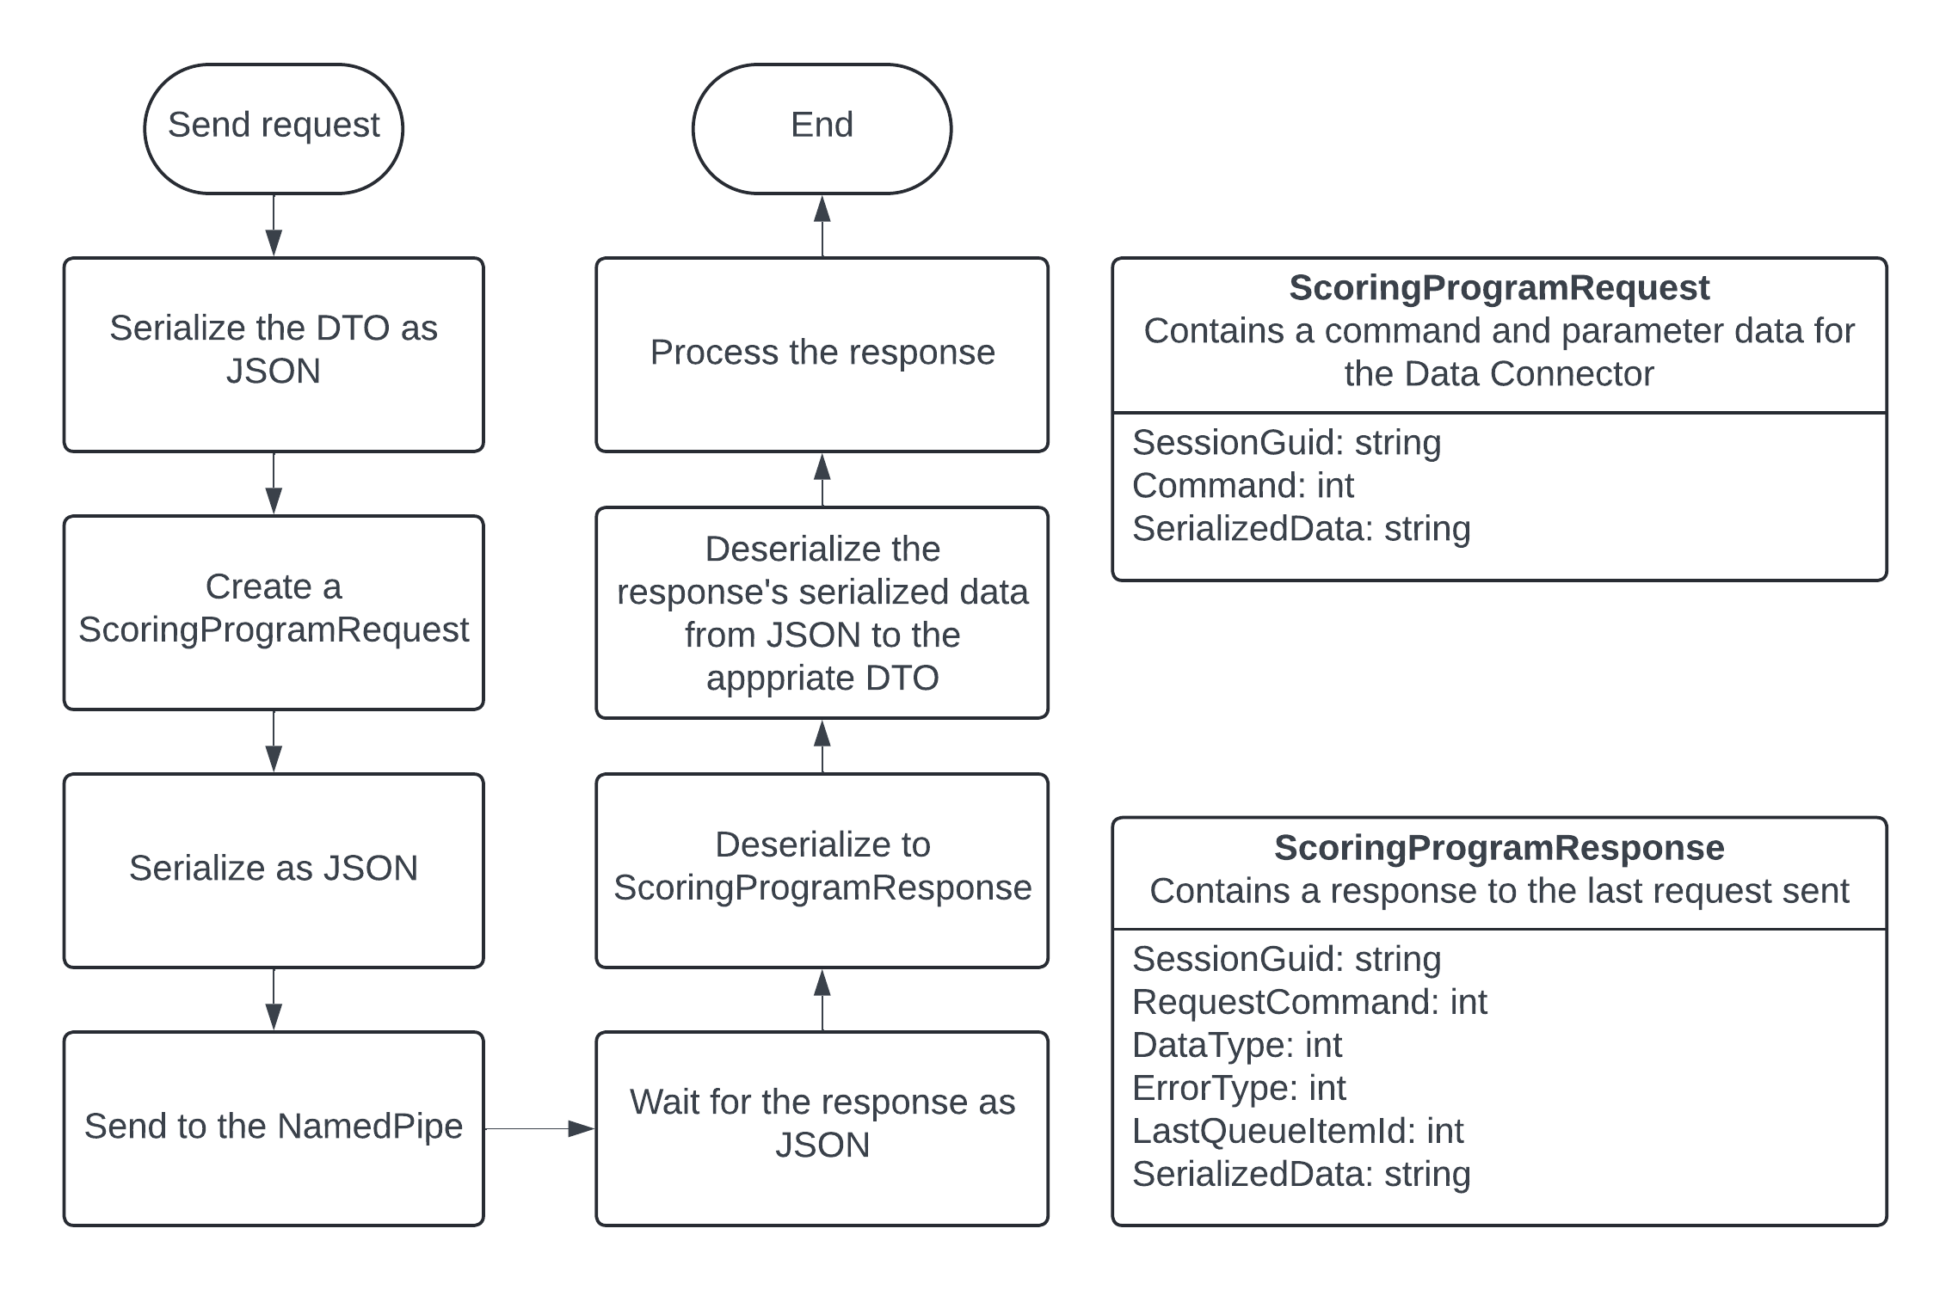

# General description

## Sending data

The scoring program wants to send a command to the Data Connector with accompanying data. The scoring program constructs a DTO containing the data the Data Connector needs to work with. The type of DTO depends on the requested action as expressed in the command. The DTO is serialized as JSON and added to a ScoringProgramRequest class.This request contains a command that specifies what Data Connector should do. The request must contain the guid of the session that the request belongs to. The request is then serialized a second time and sent to the Data Connector over the communication channel.The Data Connector will always respond. The scoring program needs to wait for this response and consume it. Otherwise communication will stall. Mind that nearly all communications are scoped to a single session as expressed by the SessionGuid property of the request. So, say, a request for new board results must be done for each session that the scoring program currently administers.

## Receiving the response

The Data Connector serializes its response data as JSON. Then it constructs a ScoringProgramResponse with this data. The response contains the original command from the request and the session guid that was sent with it in order to check if the response indeed is the answer to the request that was sent.The response has a DataType property that specifies to what DTO the JSON data can be deserialized. The scoring program waits for the response on the communication channel and deserializes it to a ScoringProgramResponse. Depending on the response's DataType the response's SerializedData can be deserialized from JSON to the appropriate DTO (or to a message).

# Overview of the commands for the ScoringProgramRequest

The tables below give a short description of the available commands for the ScoringProgramRequest and the associated DTO that must be sent with it.

## Sending data to the Bridgemate Data Connector

|  |  |  |  |  |
| --- | --- | --- | --- | --- |
| **Command** | **Value** | **Description** | **DTO** | **Remarks** |
| Connect | 1 | Connects to the communication channel | n/a | Does not transfer any data |
| Disconnect | 3 | Disconnects from the communication channel | n/a | Does not transfer any data.The communication channel will wait for a new connection. |
| Ping | 4 | Sends a string to the Data Connector and awaits its return | string | Serialize a custom string. On deserialzing the response's SerializedData the same string should return. Can be used to check if the communication channel is alive. |
| InitializeEvent | 5 | Sends start-up parameters for BCS and inititialization data | InitDTO | The InitDTO contains both start-up parameters for BCS and the data for the sessions like movements, player data and hand records. With this data a new scoring file will be created for internal use by BCS. |
| ContinueEvent | 31 | Sends start-up parameters for BCS without initialization data | n/a | Instructs the Data Connector to start up BCS if it is not running and to continue processing data using an existing scoring file |
| ManageBCS | 34 | Can send a request asking BCS to shut down immediately and can query information on administered events | BCSManagementRequestDTO | Does not transfer any data. |
| UpdateMovement | 6 | Instructs BCS to change the movement for the given section, or to delete it. | SectionDTO | The SectionDTO holds Tables as an array of TableDTOs. Each TableDTO holds Rounds as an array of RoundDTOs. Each RoundDTO contains data on the opponents and the boards played. The SectionDTO holds a IsDeleted property that can be set to 'True' if the section must be deleted.  If the section does not yet exist, it will be added. |
| UpdateScoringGroups | 8 | Instructs BCS to update its scoring groups | Array of ScoringGroupDTO | All scoring groups for the session with their sections must be sent as all sections must have a parent scoring group. Mind to use this command before adding a new section using the UpdateMovement command that has a new scoring group. |
| PutResults | 10 | Sends board results to the Data Connector | Array of ResultDTO | Using this command new or modified board results from the scoring program can be sent to the Bridgemates. |
| PutPlayerData | 11 | Sends player data to the Data Connector | Array of PlayerDataDTO | Player data contains a person's first name, last name, organization id and playernumber. The player numbers must be known to BCS before players can make themselves be known by entering their number on the Bridgemate.  The player data can be included in the InitDTO or sent seperately. The first method is more performant. |
| PutParticipations | 12 | Sends participations to the Data Connector | Array of ParticipationDTO | The participation contains information on the starting position of a player: section, table, round and seat direction. The player can either be identified by a player number, in which case the Data Connector will look up the first and last names or by first name and last name only.  The participations can be included in the InitDTO or sent seperately. The first method is more performant. |
| PutHandrecords | 13 | Sends handrecords to the Data Connector | Array of HandrecordDTO | The handrecords must have a valid scoringgroup id. Make sure to add the scoringgroup first using the UpdateScoringGroup command if a new section was added.  The handrecords can be included in the InitDTO or sent seperately. The first method is more performant. |
| PutBridgemate2Settings | 14 | Sends the Bridgemate 2 settings | Array of Bridgemate2SettingsDTO | The settings must be sent for each section seprately. The settings can be included in the InitDTO or sent seperately. The first method is more performant. |
| PutBridgemate3Settings | 15 | Sends the Bridgemate 2 settings | Array of Bridgemate3SettingsDTO | The settings must be sent for each section seprately. The settings can be included in the InitDTO or sent seperately. The first method is more performant. |

## Polling data from the Bridgemate Data Connector

|  |  |  |  |  |
| --- | --- | --- | --- | --- |
| **Command** | **Value** | **Description** | **DTO** | **Remarks** |
| PollQueueForNewResults | 19 | Polls for new board results | returns: array of ResultDTO | Returns the new board results since the last batch was acccepted. |
| PollQueueForNewPlayerData | 20 | Polls for new player data | returns: array of PlayerDataDTO | Returns the new player data since the last batch was acccepted. |
| PollQueueForNewParticipations | 21 | Polls for new participations | returns: array of ParticipationDTO | Returns the new participations since the last batch was acccepted. |
| PollQueueForNewHandrecords | 22 | Polls for new handrecords | returns: array of HandrecordDTO | Returns the new handrecords since the last batch was acccepted. |
| PollQueueForAllResults | 23 | Requests all board results, irrespective of them having been accepted before. | returns: array of ResultDTO | Returns all board results that have been created by BCS. |
| PollQueueForAllPlayerData | 24 | Requests all player data, irrespective of them having been accepted before. | returns: array of PlayerDataDTO | Returns all playerdata that has been created by BCS |
| PollQueueForAllParticipations | 25 | Requests all participations, irrespective of them having been accepted before. | returns: array of ParticipationDTO | Returns all participations that have been created by BCS |
| PollQueueForAllHandrecords | 26 | Requests all handrecords results, irrespective of them having been accepted before. | returns: array of HandrecordDTO | Returns all handrecords that have been created by BCS. |
| AcceptResultQueueItems | 27 | Signals to the Data Connector to not send board results that have been sent before. | The id as serialized integer of the last processed result queue item | Signals to the Data Connector to not send board results that have been sent before. |
| AcceptPlayerDataQueueItems | 28 | Signals to the Data Connector to not send playerdata that has been sent before. | The id as serialized integer of the last processed player data queue item | Signals to the Data Connector to not send playerdata that has been sent before. |
| AcceptParticipationQueueItems | 29 | Signals to the Data Connector to not send participations that have been sent before. | The id as serialized integer of the last participation queue item | Signals to the Data Connector to not send participations that have been sent before. |
| AcceptHandrecordQueueItems | 30 | Signals to the Data Connector to not send handrecords that have been sent before. | The id as serialized integer of the last processed handrecord queue item | Signals to the Data Connector to not send handrecords that have been sent before. |
| GetMovement | 32 | Requests the movement for a specific section | sends: sectionDTO with the desired SessionGuid and Letters.  returns: sectionDTO | The sectionDTO has Tables as an array of TableDTO, eacht table has Rounds as an array of RoundDTO. The RoundDTO contains the opponents and the board numbers that they will play. |
| GetAllMovements | 33 | Requests all movements for a session. | sends: n/a  returns: an array of SectionDTO | Each sectionDTO has Tables as an array of TableDTO, eacht table has Rounds as an array of RoundDTO. The RoundDTO contains the opponents and the board numbers that they will play. |

## Management commands

|  |  |  |  |  |
| --- | --- | --- | --- | --- |
| **Command** | **Value** | **Description** | **DTO** | **Remarks** |
| ManageBCS | 34 | Queries BCS for either the running session or all known sessions. Also used to request BCS to shut down. | sends: BCSManagementRequestDTO  returns:  BCSManagementResponseDTO | See the documentation on these DTOs. |
| ClearData | 35 | Instructs Data Connector to clear all incoming and outgoing queued and handled messages and will remove all validation data, especially the PlayerData and MovementData. | n/a | Use with caution!  Best to use only when there are no active events. Be mindful of that other clubs may have ongoing events for which not all data has been processed yet. |

## Data types

The ScoringProgramResponse has a DataType property which specifies which type of data can be expected to be in its SerializedData property.

|  |  |  |
| --- | --- | --- |
| **Value** | **Name** | **Description** |
| 1 | OK | The scoring program request was handled correctly. No serialized data is included in the response |
| 2 | Not in use |  |
| 3 | Not in use |  |
| 4 | Error | There was an error in processing the scoring program request. Examine the ErrotType property and deserialize the serialized data as a a string for detailed information |
| 5 | InitiData | Not in use for the scoring program client |
| 6 | ContinueData | Not in use for the scoring program client |
| 7 | SectionData | Not in use for the scoring program client |
| 8 | Bridgemate2Settings | Not in use for the scoring program client |
| 9 | Bridgemate3Settings | Not in use for the scoring program client |
| 10 | PlayerData | The serialized data is an array of PlayerDataDTO |
| 11 | Participations | The serialized data is an array of ParticipationDTO |
| 12 | Results | The serialized data is an array of ResultDTO |
| 13 | Handrecords | The serialized data is an array of HandrecordDTO |
| 14 | Movement | The serialized data is a SectionDTO |
| 15 | Sessions | The serialized data is an array of SectionDTO |
| 16 | EventInfo | The serialized data is BCSManagementResponseDTO containing an array of SessionInfoDTO |
| 17 | AllSessionsInfo | The serialized data is BCSManagementResponseDTO containing an array of SessionInfoDTO |
| 18 | ScoringFileLocation | The serialized data is BCSManagementResponseDTO |
| 19 | ShutDownRequest | Not in use for the scoring program client |

## Error codes

When the ScoringProgramResponse.DataType property is "Error" (4) then the ScoringProgramResponse.ErrorType property will hold a value further explaining what went wrong. Moreover the SerializedData property can be desierialized to a string to obtain detailed debugging information. This information is not meant to be shown to the end users of the external scoring program.

|  |  |  |
| --- | --- | --- |
| **Value** | **Name** | **Description** |
| 0 | None | The ScoringProgramRequest was handled succesfully |
| 1 | Busy | The ScoringProgramRequest could not be processed because a previous request has not yet been completed. Try again. |
| 2 | NoData | The ScoringProgramRequest.Command requires data to be sent with it, but there is none. |
| 3 | NoUpdates | The ScoringProgramRequest.Command included data to be updated, but the said data is already present. |
| 4 | Movement | The iincluded data did not comply to a known section, table in a section or round on a table. |
| 5 | Validation | The sent data did not pass validation. Deserialize the SerializedData to a string for details. |
| 6 | EntryUnknown | The provided data has a (composite) primary key that can not be computed. Deserialize the SerializedData to a string for details. |
| 7 | Exception | An error occurred while processing the data. Study the DataConnector.log to find details. |
| 8 | NotImplemented | The requested command is not implemented |
| 9 | EmptyResponse | The Data Connector did not respond to the request. |
| 10 | NoConnection | The communication with the Data Connector is broken |
| 11 | TimeOut | The request was blocked by a previously sent long running operation on the.Data Connector. |
| 12 | WrongDataType | The datatype of the dtos did not conform to the request command. |
| 13 | UnexpectedCommand | The response command did not conform to the request command. |
| 14 | Unknown | Unknown error. Currently not in use. |

# Code examples

Below a typical piece of code to send a request to the Data Connector and awaiting the response: using the Ping command

/// <summary>

/// Communicates to the DataConnector to see if it is responsive.

/// The Ping command returns the exact data that was sent with it.

/// </summary>

/// <returns></returns>

public async Task<ScoringProgramResponse> Ping()

{

var requestTicks = DateTime.Now.Ticks.ToString();

var serializedTicks=JsonSerializer.Serialize(requestTicks);

var response = await SendDataAsync(sessionGuid: string.Empty, ScoringProgramMiddleManCommands.Ping, serializedTicks);

if (response.RequestCommand != ScoringProgramMiddleManCommands.Ping)

{

return new ScoringProgramResponse

{

RequestCommand = ScoringProgramMiddleManCommands.Ping,

DataType = MiddleManResponseData.Error,

ErrorType = ErrorType.Unknown,

SerializedData = JsonSerializer.Serialize($"Invalid command in reponse to {nameof(ScoringProgramMiddleManCommands.Ping)}: " +

$"'{response.RequestCommand}'")

};

}

if (response.DataType != MiddleManResponseData.OK)

return response;

var responseTicks = JsonSerializer.Deserialize<string>(response.SerializedData);

var error = responseTicks != requestTicks;

return new ScoringProgramResponse

{

RequestCommand = ScoringProgramMiddleManCommands.Ping,

DataType = requestTicks == responseTicks ? MiddleManResponseData.OK : MiddleManResponseData.Error,

ErrorType = error ? ErrorType.Validation : ErrorType.None,

SerializedData = response.SerializedData

};

}

/// <summary>

/// The code that handles the actual sending of requests and reading their reponses.

/// </summary>

/// <param name="sessionGuid">Specifies which session the request targets (if any)</param>

/// <param name="command">The command to the middlleman</param>

/// <param name="serializedData">The data to send to the middleman as json data. (If any)</param>

/// <returns></returns>

private async Task<ScoringProgramResponse> SendDataAsync(string sessionGuid, ScoringProgramMiddleManCommands command, string serializedData)

{

//Construct the request to the Middleman.

var request = new ScoringProgramRequest

{

Command = command,

SessionGuid = sessionGuid,

SerializedData = serializedData

};

//Serialize it.

var requestSerialized = JsonSerializer.Serialize(request);

//Do not proceed if sending is already in progress (for an other request). There can be only on request be sent at the same time.

if (_isSending)

{

return new ScoringProgramResponse

{

RequestCommand = command,

SessionGuid = sessionGuid,

DataType = MiddleManResponseData.Error,

ErrorType = ErrorType.Busy,

SerializedData = JsonSerializer.Serialize($"Client is busy, please retry later.")

};

}

try

{

_isSending = true;

//Do not continue if the connection has been broken. Call the Connect method again then resend.

var errorResponse = CheckConnection(command);

if (errorResponse != null)

{

return errorResponse;

}

//Reconnect to the Middleman if needed.

if (!MiddleManStream.IsConnected)

{

await MiddleManStream.ConnectAsync(5000);

}

//Send the request to the Middleman. Mind: as it is written now this is a blocking call.

//However, in .Net an exception will be thrown if the connection has gone dead for whatever reason.

await MiddleManWriter.WriteLineAsync(requestSerialized);

//Wait for the response. This too is a blocking call. But in .Net a broken connection will throw an exception.

string response = await MiddleManReader.ReadLineAsync();

if (response != null)

{

var responseDeserialized = JsonSerializer.Deserialize<ScoringProgramResponse>(response);

return responseDeserialized ??

new ScoringProgramResponse

{

RequestCommand = command,

DataType = MiddleManResponseData.Error,

SerializedData = JsonSerializer.Serialize("Empty response")

};

}

else

{

return new ScoringProgramResponse

{

RequestCommand = command,

DataType = MiddleManResponseData.Error,

SerializedData = JsonSerializer.Serialize("Empty response")

};

}

}

catch (IOException)

{

CloseConnection();

return

new ScoringProgramResponse

{

RequestCommand = command,

DataType = MiddleManResponseData.Error,

SerializedData = JsonSerializer.Serialize("Pipe broken")

};

}

catch (Exception ex)

{

CloseConnection();

DebugLogger.Error(ex);

ErrorLogger.Error(ex);

return

new ScoringProgramResponse

{

RequestCommand = command,

DataType = MiddleManResponseData.Error,

SerializedData = JsonSerializer.Serialize(ex.Message)

};

}

finally

{

//Always signal that the client is free for the next items to send.

//Otherwise after an exception further communication will be blocked.

_isSending = false;

}

}

**Data Transfer Objects**

# Introduction

All data exchange between the external scoring program and the Data Connector is done using DTOs: Data Transfer Objects. How a DTO is strucured will be dependent on the programming language used. This document will use UML to show the structure of the DTOs. A DTO must be serialized as json when sent to the Data Connector. When the Data Connector responds with data, this data will also be a json-serialized DTO.

Obviously a DTO can only have public properties and have no functions.

Mind: the requests to and the responsesn from the Data Connector are layered and have two levels of json data. See the section on how to exchange data for a detailed explanation.

# Example

This is a class diagram of the TableDTO, representing a table in the session's movement.

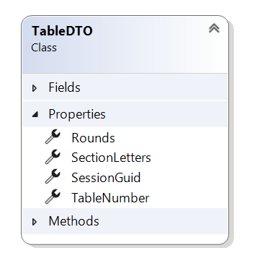

In C# the TableDTO class or struct would be something like:

public class TableDTO

{

public string SessionGuid

{

get; set;

}

public string SectionLetters

{

get; set;

}

public int TableNumber

{

get; set;

}

public RoundDTO[] Rounds

{

get; set;

}

)

while in Java it would be something like:  
  
public class TableDTO {

private String sessionGuid;

private String sectionLetters;

private int tableNumber;

private RoundDTO[] rounds;

public String getSessionGuid() {

return sessionGuid;

}

public void setSessionGuid(String sessionGuid) {

this.sessionGuid = sessionGuid;

}

public String getSectionLetters() {

return sectionLetters;

}

public void setSectionLetters(String sectionLetters) {

this.sectionLetters = sectionLetters;

}

public int getTableNumber() {

return tableNumber;

}

public void setTableNumber(int tableNumber) {

this.tableNumber = tableNumber;

}

public RoundDTO[] getRounds() {

return rounds;

}

public void setRounds(RoundDTO[] rounds) {

this.rounds = rounds;

}

}

The json serialized data for a TableDTO representing table A3 with two rounds would be something like:  
{

"SessionGuid": "4f24d8a2-2b6c-4a72-9e6a-8901a5a8b3c1",

"SectionLetters": "A",

"TableNumber": 3,

"Rounds": [

{

"SessionGuid": "4f24d8a2-2b6c-4a72-9e6a-8901a5a8b3c1",

"SectionLetters": "A",

"TableNumber": 3,

"RoundNumber": 1,

"LowBoardNumber": 9,

"HighBoardNumber": 12,

"PairNS": 5,

"PairEW": 6,

},

{

"SessionGuid": "4f24d8a2-2b6c-4a72-9e6a-8901a5a8b3c1",

"SectionLetters": "A",

"TableNumber": 3,

"RoundNumber": 2,

"LowBoardNumber": 9,

"HighBoardNumber": 12,

"PairNS": 4,

"PairEW": 8,

}

]

}

**Overview**

Below you find all Data Transfer Objects (DTOs) and their relation according to the desired action towards BCS.

### Initialization

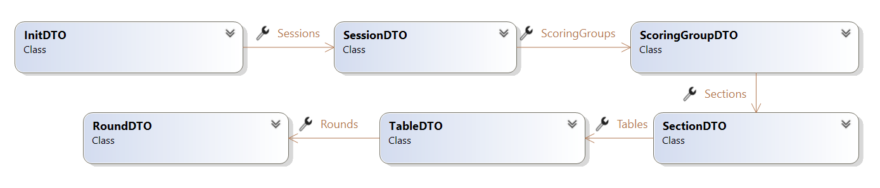

### Continuation

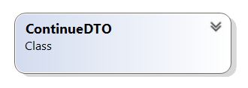

### Update Bridgemate settings

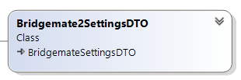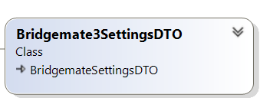

### Update scoringgroups

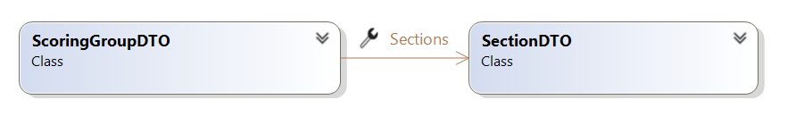

### Update movement

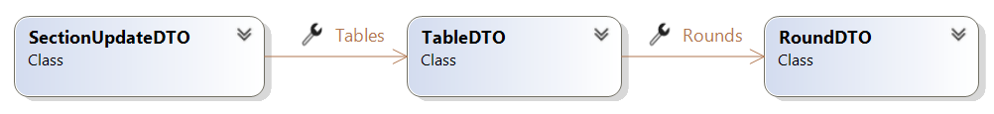

### Update handrecords

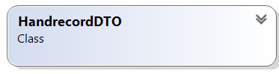

### Add session



### BCS Management

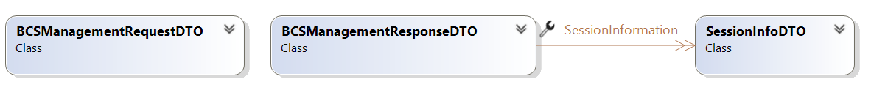

**InitDTO**

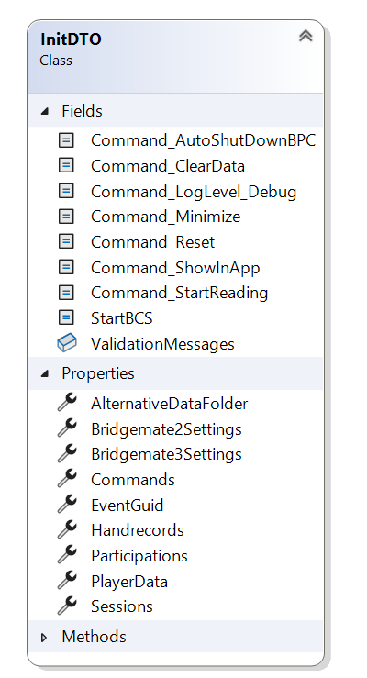

The InitDTO is used with the InitializeEvent Command.

##### Commands property

The command property is the sum of actions that BCS should perform:

|  |  |  |
| --- | --- | --- |
| Value | Description | Remarks |
| 1 | Start BCS | Instructs Bridgemate Control Software (BCS) to launch. Always include. |
| 2 | Reset | Instructs BCS to create a new scoring file based on the provided data, clear the Bridgemate servers and upload new data to them. Always include. If the data in the Bridgemates should not be cleared then use the ContinueDTO with the ContinueEvent command. |
| 4 | Start reading | Instructs BCS to start reading from the Bridgemates and the Bridgemate Data Connector. Optional |
| 8 | Show in App | Instructs BCS to upload all session to the App back-end. Alternatively this can be specified on the SessionDTOs seperately |
| 16 | Minimize | BCS will start minimized. |
| 32 | Auto shutdown | Instructs BCS to shut down after the last result has been processed. |
| 64 | Loglevel debug | Lowers the Log level from "Info" to "Debug". |
| 128 | Clear data | Instructs the Bridgemate Data Connector to clear all data. This prevents stale data of the same sessions that are contained in the InitDTO from being processed. On the other hand it will also delete data from other sessions that may await further processing. Use with caution in situations where multiple events may be ongoing. Mind that all data related to the (re)initialized event will be removed in any case. |

Typically the Commands property will be 1+2+4+128=135. The other values are optional.

##### EventGuid property

This is required when there is more than one session. When there is one session, its SessionGuid property will be reused as the event guid. This property will help discern scoring groups with the same scoring group number between events.

##### Sessions property

At least one is required. See the details on the SessionDTO for further details. The SessionDTO must contain the movement data.

##### PlayerData property

Optional. Can be sent seperately using the PutPlayerData command as well. The first name, last name of each player that could participate in the event, uniquely defined by the combination of the SessionGuid of one of the event's sessions and a PlayerNumber defined by the organization, usually the Bridge league the player is a member of.

##### Participations property

Optional. Can be sent seperately using the PutParticipations command as well. Starting positions for each player. The combination of SessionGuid and PlayerNumber must be present in the PlayerData.

##### Handrecords property

Optional. Can be sent seperately using the PutHandrecords command as well.

##### Bridgemate2Settings property

Optional. The settings for the Bridgemate II's. Can be sent seperately using the PutBridgemate2Settings command as well.

##### Bridgemate3Settings property

Optional. The settings for the Bridgemate III's.Can be sent seperately using the PutBridgemate3Settings command as well.

##### AlternativeDataFolder

Only used in advanced scenario's. Not documented here.

**ContinueDTO**

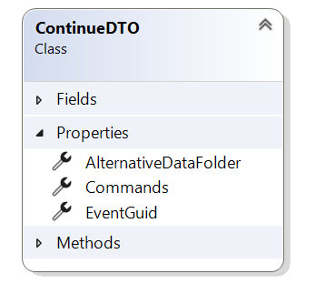

The ContinueDTO is used with the ContinueEvent command

##### EventGuid property

The guid of the event that BCS should continue administering. If the event has one session the session's SessionGuid property can be used if this property was also used in the event initialization.

##### Commands property

The command property is the sum of actions that BCS should perform after start-up:

|  |  |  |
| --- | --- | --- |
| Value | Description | Remarks |
| 1 | Start BCS | Instructs Bridgemate Control Software (BCS) to launch. Always include. |
| 4 | Start reading | Instructs BCS to start reading from the Bridgemates and the Bridgemate Data Connector. Optional |
| 16 | Minimize | BCS will start minimized. Optional |
| 32 | Auto shutdown | Instructs BCS to shut down after the last result has been processed. Optional |
| 128 | Clear data | Instructs the Bridgemate Data Connector to clear all data. This prevents stale data of the same sessions that are contained in the InitDTO from being processed. On the other hand it will also delete data from other sessions that may await further processing. Use with caution in situations where multiple events may be ongoing. |

Typically the Commands property will be 1+4=5. The other values are optional.

###### Note:

The other command values as specified for the InitDTO are invalid and if used will lead to the ContinueEvent command not being executed.

##### AlternativeDataFolder

Only used in advanced scenarios. Not documented here.

**SessionDTO**

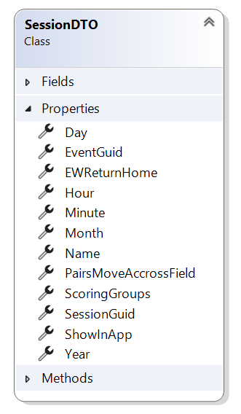

The SessionDTO can be used with the InitializeEvent command and will then be added to the InitDTO.Sessions property.

Apart from that the SessionDTO can be used as data together with AddSession command to add a session to a previously initialized event.

### EventGuid property

Optional. Must be present if there is more than one session at initialization or when the session is added to an existing event.

***SessionGuid property***

Required. A guid uniquely defining the session. Must be exactly 32 character long, uppercase and cannot contaim dashes or curly braces.

##### Name property

Optional, but recommended.

##### Year property

Required. Must be at least 2000.

##### Month property

Required. Must be between 1 and 12

##### Day property

Requred. Must be between 1 and 31. Must match with the highest day for the month

##### Hour property

Optional. Must be between 0 and 23

##### Minute property

Optional. Must be between 0 and 59

##### ShowInApp property

Signals that the session should be uploaded to the Bridgemate App.

##### ScoringGroups property

Required. Array of ScoringGroupDTOs. At least one must be present. See ScoringGroupDTO for details.

##### EWReturnHome property

Currently not supported.

##### PairsMoveAccrossField property

Currently not supported.

**ScoringGroupDTO**

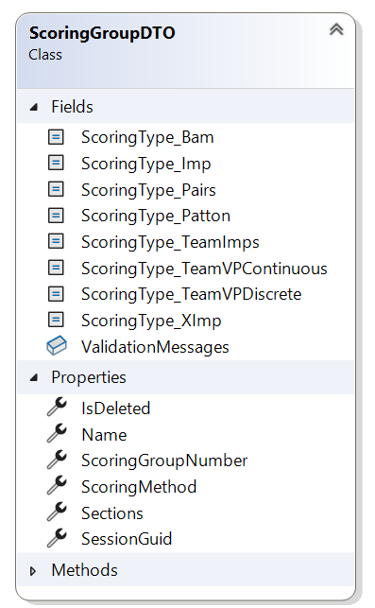

The ScoringGroupDTO defines the scoring method for its sections and is used for the score calculation: it will group the results of all the participants of its sections together. It will be part of the a SessionDTO in an InitDTO, or it can be sent seperately using the UpdateScoringGroups command.

***SessionGuid property***

Required. A guid uniquely defining the session. Must be exactly 32 character long, uppercase and cannot contaim dashes or curly braces.

##### ScoringGroupNumber property

Required. An integer value uniquely defining the scoring group within the event. Must be greater than zero.

##### ScoringMethod property

Required. Values can be:

* 10 for Matchpoints
* 20 for Imps
* 30 for Cross Imps
* 40 for Team imps
* 50 for Discrete Victory Points
* 51 for Continuous Victory Points
* 60 for Board-a-Match
* 70 for Patton

##### Name property

Optional

##### Sections property

Required. An array of SectionDTOs whose results will be calculated together as if they were one section.

##### IsDeleted property

Only used for the Update Scoringgroups command. Indicates that the scoring group has no more sections and can be deleted. Before deleting a scoring group make sure that its former sections have been assigned to a different scoring group.

**SectionDTO**

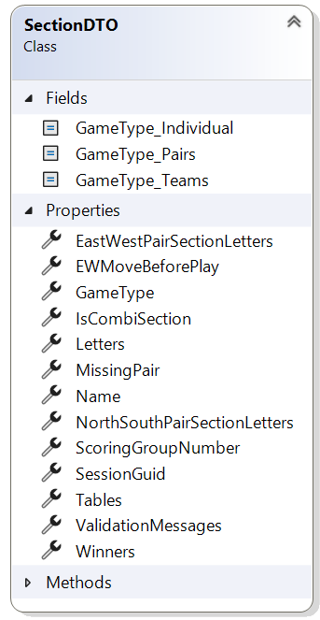

The SectionDTO contains the movement for a group of participants for the duration of the session. It will be part of a ScoringGroupDTO which is part of a SessionDTO which is part of an InitDTO.

***SessionGuid property***

Required. A guid uniquely defining the session. Must be exactly 32 character long, uppercase and cannot contaim dashes or curly braces.

##### ScoringGroupNumber

Required. The number of the ScoringGroupDTO that the section belongs to. Must be greater than zero.

##### Letters property

Required. Uniquely defines the section within the event.

##### Winners property

Required. Values can be 1 or 2. In the case of 2 winners the pair numbers in the section can be the same for North-South and East-West. Otherwise the pairnumbers in the section must be unique.

##### GameType property

Required. Values can be 10 for "Pairs", 20 for "Individual" and 30 for "Teams".

##### Name property

Optional.

##### EWMoveBeforePlay property

Currently not supported.

##### MissingPair property

Optional. If specified it will indicate the number for the pair that is not playing. Its opponents will have a sit-out when they are scheduled to play against this pair. This value can be omitted as a sit-out can also be specified on the RoundDTOs. However, if used the graphic representation of sit-out tables in BCS will be improved.

##### IsCombiSection property

Optional. If "true" the section will host the two pairs that would have otherwise have a sit-out in their own sections. Specify the section that will provide the NorthSouth pair and the section that will provide the EastWest pair.

##### NorthSouthPairSectionLetters property

Required if IsCombiSection is "true". The letters for the section where the NorthSouth pair for each round comes from.

##### EastWestPairSectionLetters property

Required if IsCombiSection is "true". The letters for the section where the EastWest pair for each round comes from.

##### Tables property

Must be present as the SectionDTO contains the movement or a movement update for the section,

Array of TableDTO.

**SectionUpdateDTO**

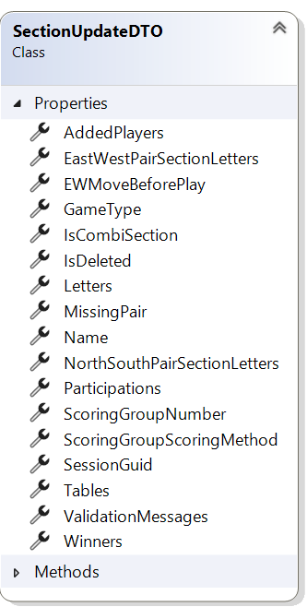

The SectionUpdateDTO contains the movement for an updated or new section or it signals that the given section must be deleted. It is sent with the UpdateMovement command. The DTO must contain infomration on the scoring group it should be added to. If the scoring group with the given ScoringGroupNumber is not yet present, it will be created.

***SessionGuid property***

Required. A guid uniquely defining the session. Must be exactly 32 character long, uppercase and cannot contaim dashes or curly braces.

##### AddedPlayers

Optional.An array of PlayerDataDTOs. Should at least contain player data for players that have not been added beofre.

##### Participations

Optional. An array of ParticipationDTOs.

##### ScoringGroupNumber

Required if IsDeleted is "False". The number of the ScoringGroupDTO that the section belongs to. Must be greater than zero.If the scoringgroup does not yet exist it will be created.

##### ScoringGroupScoringMethod

Required if the updated section belongs to a new scoring group that must be created. Valid values can be found at the information on the ScoringGroupDTO.

##### Letters property

Required. Uniquely defines the section within the event.

##### Winners property

Required. Values can be 1 or 2. In the case of 2 winners the pair numbers in the section can be the same for North-South and East-West. Otherwise the pairnumbers in the section must be unique.

##### GameType property

Required. Values can be 10 for "Pairs", 20 for "Individual" and 30 for "Teams".

##### Name property

Optional.

##### EWMoveBeforePlay property

Currently not supported.

##### MissingPair property

Optional. If specified it will indicate the number for the pair that is not playing. Its opponents will have a sit-out when they are scheduled to play against this pair. This value can be omitted as a sit-out can also be specified on the RoundDTOs. However, if used the graphic representation of sit-out tables in BCS will be improved.

##### IsCombiSection property

Optional. If "true" the section will host the two pairs that would have otherwise have a sit-out in their own sections. Specify the section that will provide the NorthSouth pair and the section that will provide the EastWest pair.

##### NorthSouthPairSectionLetters property

Required if IsCombiSection is "true". The letters for the section where the NorthSouth pair for each round comes from.

##### EastWestPairSectionLetters property

Required if IsCombiSection is "true". The letters for the section where the EastWest pair for each round comes from.

##### Tables property

Must be present if IsDeleted="False" as the SectionDTO contains the movement or a movement update for the section,

Array of TableDTO.

**TableDTO**



The TableDTO represents the location where each round two pairs will meet to play boards against each other. A table automatically has a Bridgemate associated with it.

***SessionGuid property***

Required. A guid uniquely defining the session. Must be exactly 32 character long, uppercase and cannot contaim dashes or curly braces.

##### SectionLetters property

Required. Refers to the section the table is part of.

##### TableNumber property

Required. Uniquely defines the table in the section.

##### Rounds property

Required if the TableDTO is part of an InitDTO. If the TableDTO is part of a movement update, zero rounds means that the table should be deleted. An array of RoundDTOs.

**RoundDTO**

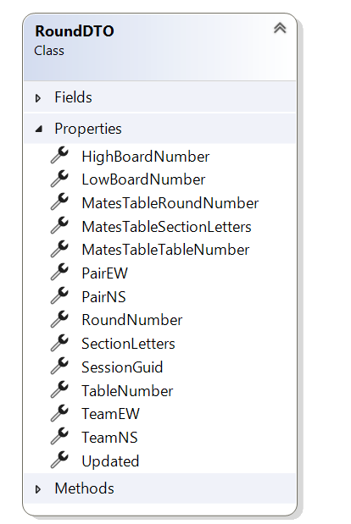

The RoundDTO defines which pairs play on its table in the specified round and which boards they will play. Currently only consecutive boards are supported.

***SessionGuid property***

Required. A guid uniquely defining the session. Must be exactly 32 character long, uppercase and cannot contaim dashes or curly braces.

##### SectionLetters property

Required. Refers to the section the table is part of.

##### TableNumber property

Required. Uniquely defines the table in the section

##### RoundNumber property

Required. Uniquely defines the round on its table.

##### PairNS property

The number of the pair that takes the North-South position.If the value is greater than zero and if the section has one winner the number must be unique within all rounds with the same number in the section. If the section has two winners the number must be unique within all PairNS values within all rounds with the samen number in the section. A value of zero will indicate a sit-out if the PairEW value is greater than zero or an empty table if PairEW is zero too.

##### PairEW property

The number of the pair that takes the East-West position. If the value is greater than zero and if the section has one winner the number must be unique within all rounds with the same number in the section. If the section has two winners the number must be unique within all PairEW values within all rounds with the samen number in the section. A value of zero will indicate a sit-out if the PairNS value is greater than zero or an empty table if PairNS is zero too.

##### LowBoardNumber property

The number of the lowest board that the pairs will play. Together with the high board number property the value defines all boards that the pairs will play against each other.

##### HighBoardNumber property

The number of the highest board that the pairs will play. Together with the low board number property the value defines all boards that the pairs will play against each other.

##### TeamNS property

Optional. The number of the team for the North-South pair.

##### TeamEW property

Optional. The number of the team for the East-West pair.

##### MatesTableSectionLetters property

Optional. The letter of the section where the two other pairs of the teams match will play the same boards.

##### MatesTableTableNumber property

Optional. The number of the table where the two other pairs of the teams match will play the same boards.

##### MatesTableRoundNumber property

Optional. The number of the round where the two other pairs of the teams match will play the same boards.

##### Updated

Not in use for external scoring programs.

**ResultDTO**

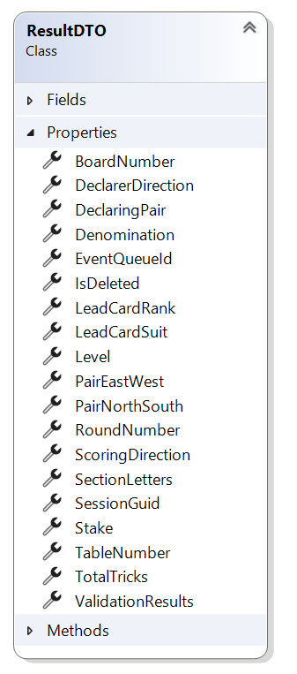

Represents the result on a board. Both natural and artificial results can be expressed, It is possible to send seperate results for the North-South scoring side and East-West scoring side, but currently Bridgemate Control Software, the Bridgemate App and the Bridgemate servers do not support this.

***SessionGuid property***

Required. A guid uniquely defining the session. Must be exactly 32 character long, uppercase and cannot contaim dashes or curly braces.

##### SectionLetters property

Required. Specifies the section in whicht the result was obtained.

##### TableNumber property

Required. Specifies the table on which the result was obtained.

##### RoundNumber property

Required. Specifies the round in which the result was obtained.

##### BoardNumber property

Required. Specifies the board on which the result was obtained.

##### ScoringDirection property

Required (cannot be zero). 1 for North-South, 2 for East-West, 3 for both, i.e.: no split score. As split scores for North-South and East-West currently are not supported use 3 always.

##### PairNorthSouth property

The number of the pair in the North-South position.

##### PairEastWest property

The number of the pair in the East-West position.

##### DeclaringPair property

Either the value of the PairNorthSouth property or the PairEastWest property.

##### DeclarerDirection property

Specifies the declarer on the board. Possible values are:

* 0: NA
* 1: North
* 2: East
* 3: South
* 4: West

**Note**  
When the declarer direction property is North or South while the de declaring pair is the East-West pair the result is marked as being a switched seating. Likewise for East or West and the North-South pair.

##### Level property

Represent the level of the contract: 1 to 7 for natural scores and:

|  |  |  |
| --- | --- | --- |
| Value | Meaning | Comment |
| 0 | Pass |  |
| -1 | Avg minus/Avg minus | Both sides get Average minus |
| -2 | Avg minus/ Avg | Average minus for the scoringdirection, Average for the opponents. When scoring direction is 3 it is handled as 1 (North-South) |
| -3 | Avg minus/Avg plus | Average minus for the scoringdirection, Average plus for the opponents. When scoring direction is 3 it is handled as 1 (North-South) |
| -4 | Avg/Avg minus | Average for the scoringdirection, Average minus for the opponents. When scoring direction is 3 it is handled as 1 (North-South) |
| -5 | Avg/Avg | Average for both sides. |
| -6 | Avg/Avg plus | Average for the scoringdirection, Average plus for the opponents. When scoring direction is 3 it is handled as 1 (North-South) |
| -7 | Avg plus/Avg minus | Average plus for the scoringdirection, Average minus for the opponents. When scoring direction is 3 it is handled as 1 (North-South) |
| -8 | Avg plus/Avg | Average plus for the scoringdirection, Average for the opponents. When scoring direction is 3 it is handled as 1 (North-South) |
| -9 | Avg plus/Avg plus | Average plus for both sides |
| -10 | No play | The board was cancelled. |

##### Denomination property

The denomination for the contract, if applicable. Possible values are:

* 0: N/A (Pass, No play, artificial score)
* 1: Clubs
* 2: Diamonds
* 3: Hearts
* 4: Spades
* 5: No Trump

##### Stake property

Specifies if the contract was doubled or redoubled. Possible values are:

* 0: Not doubled
* 1: Doubled
* 2: Redoubled

##### TotalTricks property

Specifies the total number of tricks that were obtained by the declaring side. Zero if N/A.

##### LeadCardRank property

Optional. The rank of the lead card, if specified. Possible values are:

* 0: N/A
* 2-10: the card value
* 11: Jack
* 12: Queen
* 13: King
* 14: Ace

##### LeadCardSuit property

Optional, required if the lead card rank is other than zero. The suit of the leadcard. Possible values are:

* 0: N/A
* 1: Clubs
* 2: Diamonds
* 3: Hearts
* 4: Spades

**PlayerDataDTO**

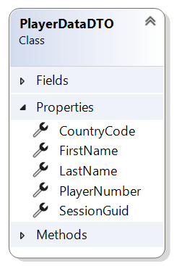

The PlayerDataDTO contains the name and identification data for a player that may compete in a specific session.

The player is uniquely defnied by the combination of SessionGuid and PlayerNumber. Both values are therefor required.

**Note**

Because of the above a player must be sent to Bridgemate Data Connector for each session that it may compete it.

If players can make themselved known at their first table by entering their player number on the Bridgemate make sure that all for all possible players a PlayerDataDTO has been sent for that session.

The PlayerDataDTO can be used as part of the InitDTO for the event initialization, or it can be sent as data for the PutPlayerData command.

***SessionGuid property***

Required. A guid uniquely defining the session. Must be exactly 32 character long, uppercase and cannot contaim dashes or curly braces.

##### PlayerNumber property

Required. Uniquely defines the player (for this session).

##### FirstName property

Optional. The first name of the player.

##### LastName property

Required. The last name of the player.

##### CountryCode property

Currently not supported.

**ParticipationDTO**

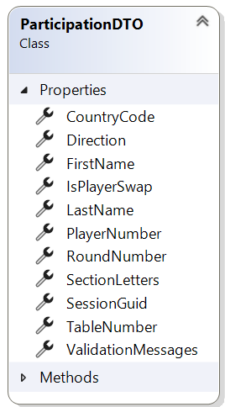

'The ParticipationDTO specifies for each round on a table which players occupy the four seats, Only specify partiicipation for known players.

The ParticipationDTO can be used in three ways:

1. By specifiying the SessionGuid and PlayerNumber. Make sure that a corresponding PlayerDataDTO with the same SessionGuid and PlayerNumber has been sent before sending the participation.Do not include first name or last name of the player.
2. By specifying the SessionGuid and at least the PlayerLastName. Internally Bridgemate Data Connector will make a registration of this player. Do not include the player number of the player.
3. An array of ParticipationDTO will be returned by the PollQueueForNewParticipations command. In this case the IsPlayerSwap property could have a value of "True".

In theory you could send all participations for all rounds. However, currently this is not supported.Bridgemate Control Software will determine the participations for round two and higher from the movement as sent with the SectionDTO. So leave the RoundNumber at zero, or set it to 1.

You can send the participations as part of the InitDTO when initializing a new event. Or they can be sent seperatly as data for the PutParticipations command.

***SessionGuid property***

Required. A guid uniquely defining the session. Must be exactly 32 character long, uppercase and cannot contaim dashes or curly braces.

##### SectionLetters property

Required. Specifies the section for the participation.

##### TableNumber property

Required. Specifies the table for the participation.

##### RoundNumber property

Currently not supported.

##### Direction property

Required. Represents the seating for the player: North, East, South or West.

##### PlayerNumber property

Optional. Together with the SessionGuid uniquely defnines the player. The player must have been sent to Bridgemate Data Connector using a PlauerDataDTO beforehand.Do not include first name or last name.

##### FirstName property

Optional .Leave empty when a player number has been specified.

##### LastName property

Optional. Required if no player number has been specified. Leave empty when a player number has been specified.

##### CountryCode property

Currently not supported.

##### IsPlayerSwap property

Can only be "True" after a PollQueueForNewParticipations command. Signals that the North player was swapped with the South player, or that the East player was swapped with the West player. The Direction ans PlayerNumber properties reflect the values after the swap.

**Bridgemate2SettingsDTO**

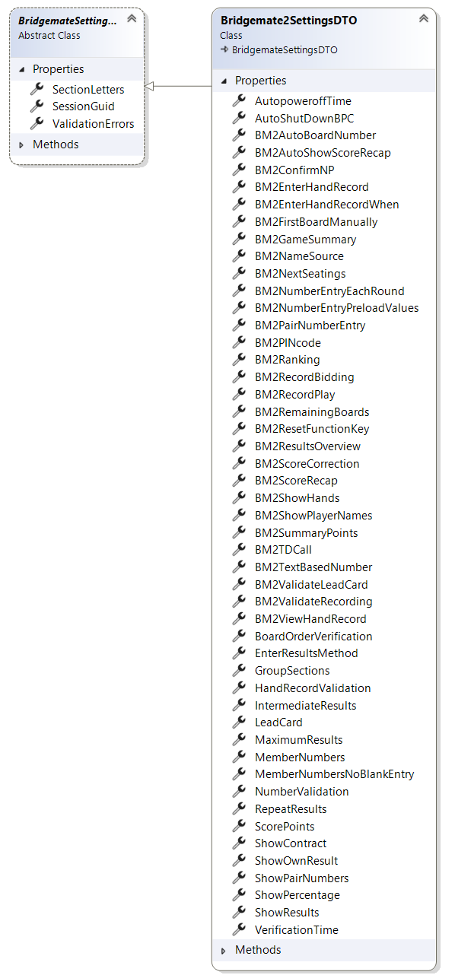

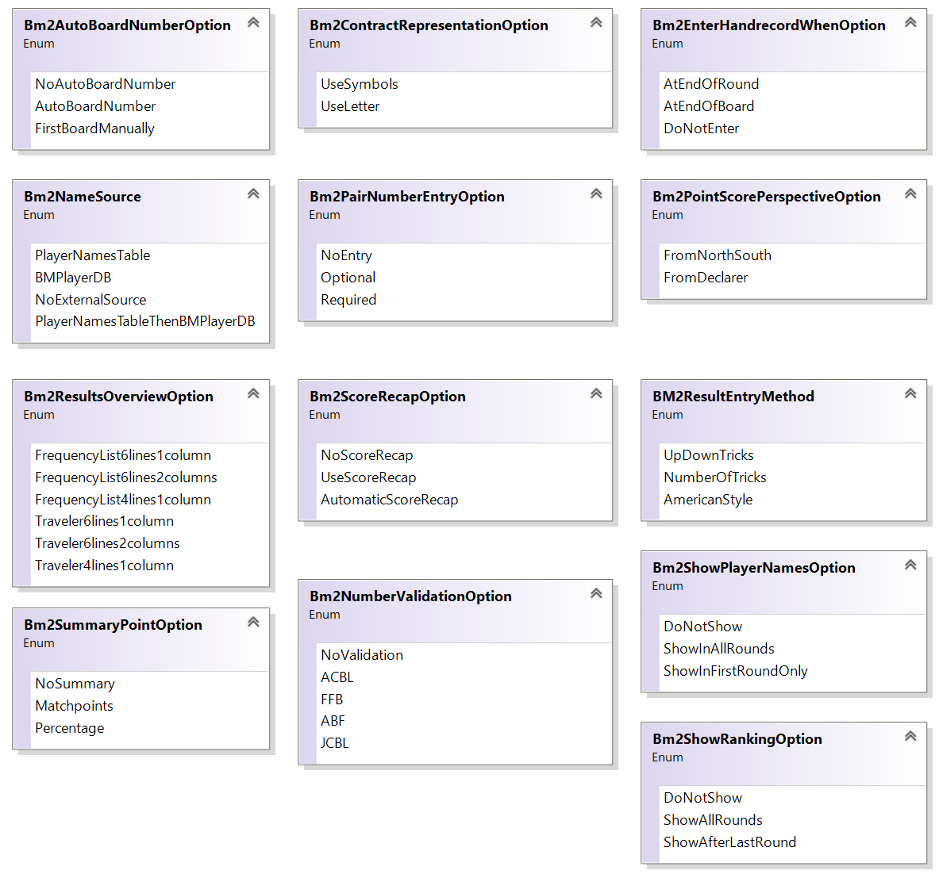

The Bridgemate2SettingsDTO contains all settings for the Bridgemate 2. It can be used as part of the InitDTO for the intitialization of an event, or

it can be used as data for the PutBridgemate2Settings command to update settings. When used all settings must be provided.For readability many of the settings are expressed as enum values. This is not necessary, the use of integer values is allowed as well. In the image above the enum values will always be consecutively numbered starting wit zero. So Bm2ShowRankingOption.DoNotShow equals to zero and Bm2ShowRankingOption.ShowAfterLastRound equals to two.

The settings will be applied to all Bridgemate 2s for a section.The settings must be provided for each section, even if they are the same.

**Note**

In the diagram the Bridgemate2SettingsDTO is depicted as a child of the abstract BridgemateSettingsDTO. The latter's properties can be considered to be part of the Bridgemate2SettingsDTO.

***SessionGuid property***

Required. A guid uniquely defining the session. Must be exactly 32 character long, uppercase and cannot contaim dashes or curly braces.

##### SectionLetters property

Required. Identifes the section that the settings pertain to.

##### AutopoweroffTime property

Byte. Specifies the number of seconds after which the display will power off.

##### AutoShutDownBPC property

Boolean. Specifes if Bridgemate Control Software should shut down after the last result has been processed.

##### BM2AutoBoardNumber property

Integer/Enum (Bm2AutoBoardNumberOption).Specifies if the Bridgemate should fill in the boardnumber automatically, Also see the BM2FirstBoardManually setting.

##### BM2AutoShowScoreRecap property

Boolean. Specifies if the scores obtained should be displayed for review after the last result has been entered for each round. All obtained results will be shown as well after the play of the last board.

##### BM2ConfirmNP property

Boolean. Specifies if the TD must come to the table to confirm No play on the Bridgemate.

##### BM2EnterHandrecord property

Boolean. Specifies if the players can enter the handrecord for a board. If "true" then the BM2EnterHandrecordWhen setting determines when the handrecord may be entered.

##### BM2EnterHandrecordWhen property

Integer/Enum (Bm2EnterHandrecordWhenOption).Specifies when the players can enter the handrecord on the Bridgemate. The default value is zero: after all boards for the round have been played.

##### BM2FirstBoardManually property

Boolean. If the BM2AutoBoardNumber setting is "True" this setting further specifies if the board number for the first board played should be entered manually.

##### BM2GameSummary property

Boolean.If "True" shows the summary of the session after the last board has been entered.

##### BM2NameSource property

Currently not supported. Player names for at least all competing players should be sent to the Data Connector using PlayerDataDTOs.

##### BM2NextSeating property

Boolean. Specifies it the Bridgemate should show the table for the next round after the last result has been entered for the current round.

##### BM2NumberEntryEachRound property

Boolean. If "True" the players must enter their player number at the start of each round.

##### BM2NumberEntryPreloadValues property

Boolean.If player numbers are entered each round, preload known player numbers.

##### BM2PairNumberEntry property

Integer/Enum (Bm2PairNumberEntyOption). Specifies if when entering a result the declaring pair must be entered.

##### BM2PINcode property

String of four digits. Optional.Defaults to "0000".

##### BM2Ranking property

Integer/Enum (Bm2ShowRankingOption). Specifies if and when the current ranking for the pairs should be shown.

##### BM2RecordBidding property

Boolean. Currently not supported.

##### BM2RecordPlay property

Boolean. Currently not supported.

##### BM2RemainingBoards property

Boolean. If "True" the Bridgemate will show how many boards remain to be played.

##### BM2ResetFunctionKey property

Boolean. If "True" the reset function key will be available from the TD menu without having to enter the PIN code first.

##### BM2ResultsOverview property

Integer/Enum (Bm2ResultsOverviewOption). Specifies how the previous results on the board should be shown. Either as frequency list (show number of times a specific contract was played) or as traveler (show the result for each pair).

##### BM2ScoreCorrection property

Boolean. If "True" allows the players to erase a result in the round on their table and to enter it again.

##### BM2ScoreRecap property

Boolean. If "True" the Bridgemate will show a "Scores" button to check the entered results for the round.

##### BM2ShowHands property

Boolean. Currently not supported.

##### BM2ShowPlayerNames property

Integer/Enum (Bm2ShowPlayerNamesOption). Specifies if and when the playernames shoud be shown on the Bridgemate at the start of a round.

##### BM2SummaryPoints property

Integer/Enum (Bm2SummaryPointsOption). If the BM2GameSummary is "True" specifies whether the obtained results per board should be shown as matchpoints or as a percentag. For this to work the BM2RankingProperty must be either ShowAllRounds (1) or ShowAfterLastRound (2).

##### BM2TDCall property

Boolean. If "True" specifies that the players can call the Tournament Director from the Bridgemate.

##### BM2TextBasedNumber property

Currently not supported. Player numbers can be set using the PlayerDataDTO. The player number is stored as a string.

##### BM2ValidateLeadCard property

Boolean. If "True" The entered lead card will be checked against the handrecord.

##### BM2ValidateRecording property

Currently not supported.

##### BM2ViewHandRecord property

Boolean. If "true" the players get the option to view the handrecord after entering the result.

##### BoardOrderVerification property

Boolean. If "True" the Bridgemate will check the order of entry of the boardnumbers.

##### EnterResultsMethod property

Integer/Enum (Bm2ResultsEntryOption). Specifies how the resulting tricks after play must be entered.

##### GroupSections property

Not supported. Use the ScoringGroupDTO to indiciate that sections should be scored together.

##### HandRecordValidation property

Boolean. Currently not supported.

##### Intermediate results property

Boolean. Currently not supported.

##### LeadCard property

Boolean. If "True" specifies that the leadcard must be entered along with the cotnract.

##### MaximumResults property

Integer (0-127). Specifies the maximum number of results to show. Zero means "unlimieted".

##### MemberNumber property

Boolean. If "True" the Bridgemate will ask for playernumbers at the start of a round when for that round there are participations without a player number.

##### MemberNumbersNoBlankEntry property

Boolean If "True" entry of player numbers cannot be skipped,

##### NumberValidation property

Currently not supported.

##### RepeatResults property

Boolean. If "True" allows the players to review the results of a round again.

##### ScorePoints property

Integer/Enum (Bm2PointScorePerspectiveOption). Show score points from perspective of North-South or from declarer.

##### ShowContract property

Integer/Enum (Bm2ContractRepresentationOption). Specifies if the denomination of the contract should be shown with letters or symbols.

##### ShowOwnResult property

Boolean. If "True" specifies that the own result should be included in the result overview.

##### ShowPairNumbers property

Boolean. If "True" the pair numbers for the current round will be displayed on the Bridgemate.

##### ShowPercentage property

Boolean. If "True" show the percentage obtained on the board just played.

##### ShowResults property

Boolean. If "True" show previous results on the board just played.

##### VerificationTime property

Integer (1-7) The time in seconds that the verification message is shown before the opponents get to confirm the result on the board just played.

**Bridgemate3SettingsDTO**

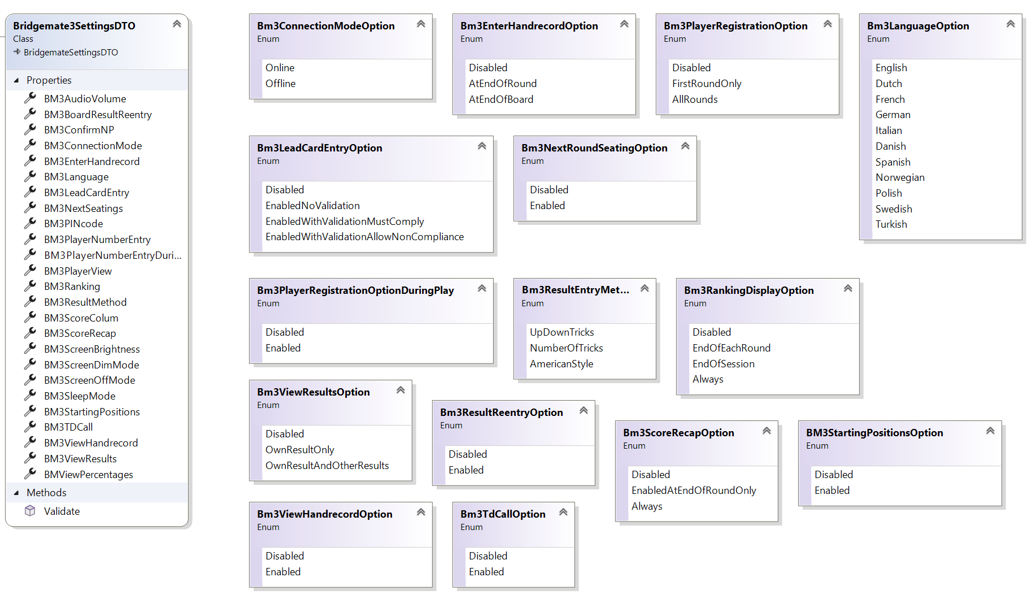

The Bridgemate3SettingsDTO contains all settings for the Bridgemate 3. It can be used as part of the InitDTO for the intitialization of an event, or

it can be used as data for the PutBridgemate3Settings command to update settings. When used all settings must be provided.For readability many of the settings are expressed as enum values. This is not necessary, the use of integer values is allowed as well. In the image above the enum values will always be consecutively numbered starting wit zero. So Bm3ViewResultsOption.Disabled equals to zero and Bm3ViewResultsOption.OwnResutlsAndOtherResults equals to two.

The settings will be applied to all Bridgemate 3s for a section.The settings must be provided for each section, even if they are the same.

**Note**

In the diagram the Bridgemate3SettingsDTO is depicted as a child of the abstract BridgemateSettingsDTO. The latter's properties can be considered to be part of the Bridgemate3SettingsDTO.

***SessionGuid property***

Required. A guid uniquely defining the session. Must be exactly 32 character long, uppercase and cannot contaim dashes or curly braces.

##### SectionLetters property

Required. Identifes the section that the settings pertain to.

##### BM3AudioVolume property

Integer (0-7). Currently not in use.

##### BM3ConnectionMode property

Integer/Enum (BM3ConnectionModeOption). Specifies if the Bridgemates for this section will operate in offline mode. In offline mode the Bridgemate will not communicate with the Bridgemate 3 server during the session, but will try to send its results after the last board had been played.

##### BM3EnterHandrecord property

Integer/Enum (BM3EnterHandrecordOption). Specifies if and when the players can enter the handrecord for a board if it is not present.

##### BM3Language property

Integer/Enum (BM3LanguageOption). Specifies which language the Bridgemate will use. The default is zero for English.

##### BM3LeadCardEntry property

Integer/Enum (BM3LeadCardEntryOption). Specifies if the leadcard must be enterd together with the contract and if the leadcard should be validated againts the handrecord.

##### BM3NextSeatings property

Integer/Enum (BM3NextRoundSeatingOption).Specifes if the seatings for the next round must be displayed after the last result has been entered for the round.

##### BM3PlayerNumberEntry property

Integer/Enum (BM3PlayerRegistrationOption). Specifies if and when the players can make themselves known by entering their playernumber and/or name on the Bridgemate.

##### BM3PlayerVIew property

Integer/Enum (BM3PlayerViewOption). Specifies if the windrose showing the players will have the North seat on top (0) or North on the bottom (1).

##### BM3PlayerNumberEntryDuringPlay property

Integer/Enum (BM3PlayerRegistrationOptionDuringPlay). Specifies if and when the players can make themselves known by entering their playernumber and/or name on the Bridgemate while the round is in progress (i.e.: after a board has been entered).

##### BM3Ranking property

Integer/Enum (BM3RankingDisplayOption). Specifies if and when the Bridgemate will show the current ranking for the players on the table.

##### BM3ResultMethod property

Integer/Enum (BM3ResultMethodOption). Specifies how players can enter the result for a board: Up/Down tricks, total tricks or American style.

##### BM3BoardResultReentry property

Integer/Enum (BM3ResultReentryOption). Specifies if players may reenter the result of the board after the original entry has been confirmed by the opponents.

##### BM3ScoreColumn property

Integer/Enum (BM3ScoreColumnOption). Specifies if the result overview will show one column for North-South only (0) or one for both North-South and East-West (1).

##### BM3ScoreRecap property

Integer/Enum (BM3ScoreRecapOption). Specifies if and when the Bridgemate will show a recap of the scores obtained on the table in the current round.

##### BM3ScreenBrightness property

Integer (1-7) Defines the screen brightness.

##### BM3ScreenDimMode property

Integer (0-15). Defines the number of seconds (times 5) before the screen of the Bridgemate will dim. So the default value of 2 amounts to 10 seconds.

##### BM3ScreenOffMode property

Integer (0-15). Defines the number of seconds (times 5) before the screen of the Bridgemate will turn off. A value of zero, the default, means "never turn off".

##### BM3SleepMode property

Integer (0-120). Defines the number of seconds (times 5) befote the Bridgemate will enter Sleepmode. Once the Bridgemate has entered sleepmode its powerbutton must be used to wake it up again.

##### BM3StartingPositions property

Integer/Enum (BM3StartingPositionsOption). Specifies if the players should confirm their seating before play starts.

##### BM3TDCall property

Integer/Enum (BM3TdCallOption). Specifies if players can call for the Tournament Director using the Bridgemate.

##### BM3PinCode property

A string of four digits. The code the TD must enter to get access to the TD menu. Defaults to "0000".

##### BM3ComfirmNP property

Integer/Enum (BM3ComfirmNPOption). Specifies if the TD must confirm a No Play result on the Bridgemate.

##### BM3ViewHandrecord property

Integer/Enum (BM3ViewHandrecordOption). Specifies if players may view the handrecord after the result has been entered.

##### BM3ViewPercentages property

Integer/Enum (BM3ViewPercentagesOption). Specifies if the percentage score should be shown (1) rather than the matchpints (0) .

##### Bm3ViewResults property

Integer/Enum (BM3ViewResultsOption). Specifies if the Bridgemate will show the other results for the board that was just entered.

**BCSManagementRequestDTO**

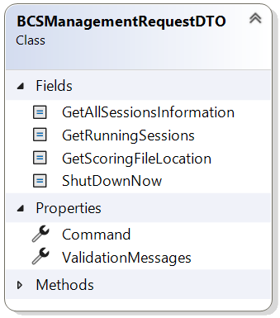

The BCSManagementDTO can be used to send a shut down request to Bridgemate Control Software. It can also be used to query some data about what events are known and which of them currently is being administered. Last it is possible to ask for the location of the scoring file in order to include this in back-ups.

Depending on the given command the request will return different data.The BCSManagemenRequetDTO is sent with a ManageBCS command

Below are the commands that can be given and their effects:

|  |  |  |
| --- | --- | --- |
| **Command** | **Effect** | **Returns** |
| 1: ShutDownNow | Sends a request to BCS to shut down immediately, Mind that this can cause previous data that was sent not to be processed. | A ScoringProgramResponse with its DataType set to OK or an error code. No serialized data is returned. |
| 2: GetRunningSessions | Queries which event is currently being administered. | A ScoringProgramResponse with as DataType EventInfo or an errorcode. The SerializedData property contains a BCSManagementResponseDTO. |
| 4: GetScoringFileLocation | Queries which scoring file is currently in use and where it is located. | A ScoringProgramResponse with as DataType ScoringFileLocation or an errorcode. The SerializedData property contains a BCSManagementResponseDTO. |
| 8: GetAllSessionsInformation | Queries which events are present in the current scoring file. | A ScoringProgramResponse with as DataType AllSessionsInfo or an errorcode. The SerializedData property contains a BCSManagementResponseDTO. |
| 6: 2+4 | Combines the two commands | A ScoringProgramResponse with as DataType EventInfo or an errorcode. The SerializedData property contains a BCSManagementResponseDTO. |

**BCSManagementResponseDTO**

#### 

#### The BCSManagementResponseDTO

The BCSManagementResponseDTO is returned for a BCSManagementCommand that asks for session information and/or the scoringfile path.

##### EventGuid property

The guid of the current event being administerd by Bridgemate Control Software. Will be empty if IsRunning is "False" or when the BCSManagementRequestDTO.Command property contains GetAllSessionsInformation (8).

##### IsRunning property

If "True" BCS is running.

##### ScoringFilePath property

The full path to BCS's scoring file. Can be used to make and restore back-ups.

#### The SessionInfoDTO

The SessionInfoDTO contains either information on the sessions that BCS currently administers (BCSManagementRequestDTO.Command contains GetRunningSessions (2) or information on all known sessions in the scoring file (BCSManagementRequestDTO.Command contains GetAllSessionsInformation (8) . It will only contain data when IsRunning is "True".

##### EventGuid property

The guid of the event the session belongs to.

##### SessionDateTime property

The date and time when the session started,

##### SessionGuid property

The guid of the session.

##### SessionName property

The name of the session.

**HandrecordDTO**

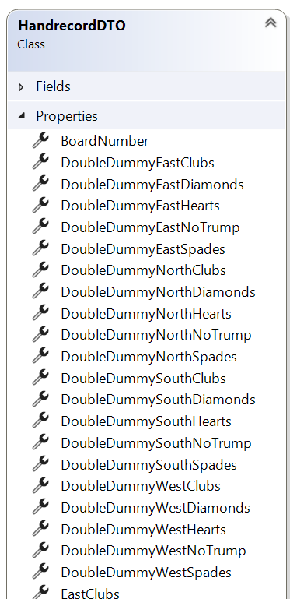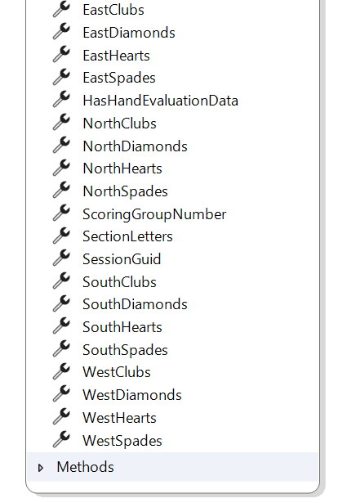

The HandrecordDTO contains the cards of each hand for a ScoringGroupDTO. Moreover it can contain double dummy data,

HandrecordDTOs can be sent as part of the InitDTO when initializing a new event. Or they can be sent seperatly as data for the PutHandrecordsCommand.

**Note**

The handrecords are identified using the SessionGuid and Sectionletters properties, However, handrecords must be unique for each scoringgroup. When a scoringgroup has more than one section it suffices to send the handrecords for only one of these sections.

***SessionGuid property***

Required. A guid uniquely defining the session. Must be exactly 32 character long, uppercase and cannot contaim dashes or curly braces.

##### SectionLetters property

Required. Together with the SessioGuid, the ScoringGroupNumber and BoardNumber it uniquely defines the handrecord.co

##### ScorinGroupNumber property

Required. Together with the SessioGuid, SectionLetters and BoardNumber it uniquely defines the handrecord.

##### BoardNumber property

Required.Together with the SessioGuid,ScoringGroupNumber and SectionLetters it uniquely defines the handrecord.

##### NorthClubs...WestSpades properties

Required. Strings that define the cards for a hand. Valid values are A K Q J T 9 8 7 6 5 4 3 2. Leave empty for a void. Note that the ten must be represented as 'T'.

##### HasHandEvaluationData property

Optional. Specifies if double dummy analasis data is included.

#### DoubleDummyNorthClubs...DoubleDummyWestNoTrump properties

Optional. Specifies the total number of tricks that can be made given the declarer and denomination.

**Procedures**

**Initialize an event**

### Procedure

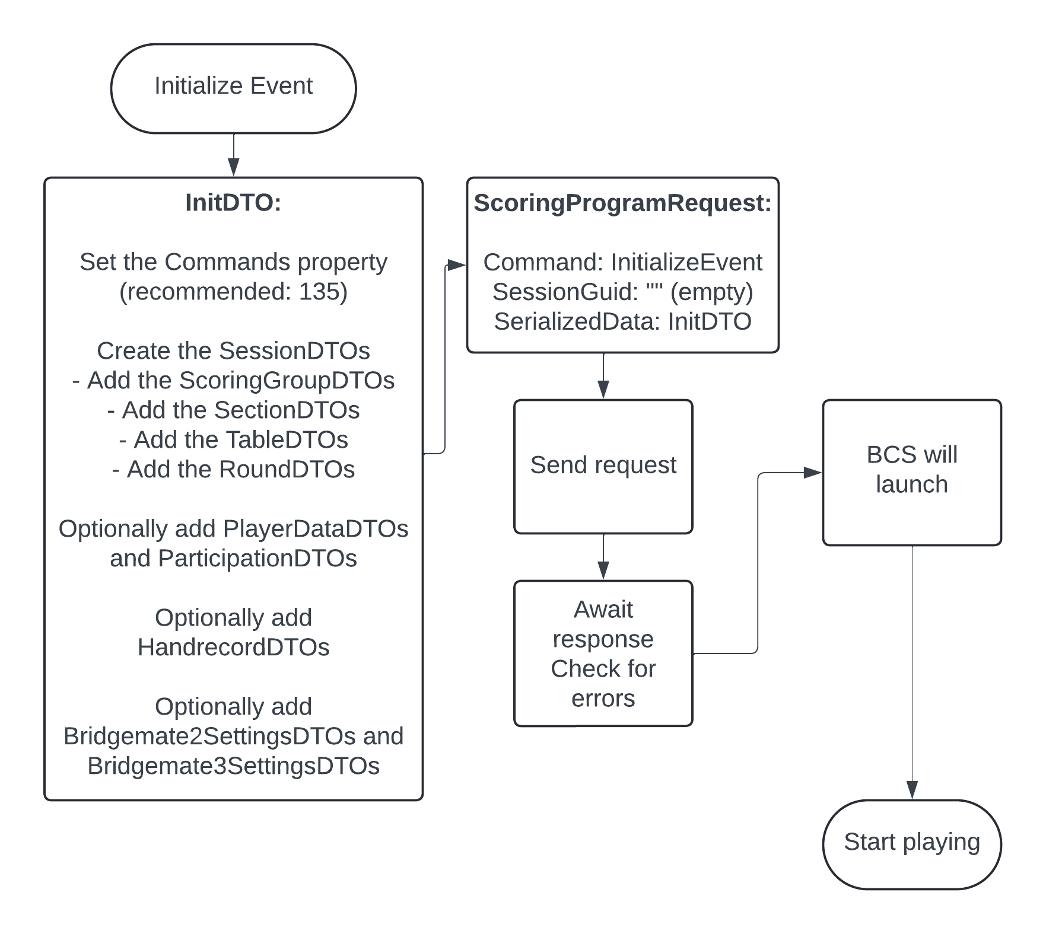

### Data structure



### Description

An event can be initialized with one or more sessions.Initialization is done using the InitializeEvent command and an InitDTO. The SessionGuid must not be set in the ScoringProgramRequest. This DTO must at least contain information on the scoring method, the scoring group for each section and the movement.

Player data, starting posititons and handrecords are optional. Board results are no part of initialization data but can be sent later.N

Furthermore, the InitDTO contains a Commands property that specifies which actions the Bridgemate Control Software must undertake when it has been launched.

**Note**

A player, as identified by his playernumber, may only exist once in the event. In the case that a player participates in both events make sure to duplicate the player with a different playernumber.

### Example json code

The code below shows the minimum required json data to send to initialize a session with four pairs that all meet each other.

{

"Command": 5,

"SessionGuid: """,

"SerializedData":

{

"Commands": 135,

"EventGuid": "6D115AF1ABEB4462A299B1FE86274949",

"AlternativeDataFolder": null,

"Sessions": [

{

"ScoringGroups": [

{

"SessionGuid": "6D115AF1ABEB4462A299B1FE86274949",

"Sections": [

{

"SessionGuid": "6D115AF1ABEB4462A299B1FE86274949",

"ScoringGroupNumber": 1,

"Letters": "A",

"Name": null,

"Winners": 1,

"GameType": 10,

"EWMoveBeforePlay": 0,

"MissingPair": 0,

"IsCombiSection": false,

"NorthSouthPairSectionLetters": null,

"EastWestPairSectionLetters": null,

"IsDeleted": false,

"Tables": [

{

"SessionGuid": "6D115AF1ABEB4462A299B1FE86274949",

"SectionLetters": "A",

"TableNumber": 1,

"Rounds": [

{

"SessionGuid": "6D115AF1ABEB4462A299B1FE86274949",

"SectionLetters": "A",

"TableNumber": 1,

"RoundNumber": 1,

"LowBoardNumber": 1,

"HighBoardNumber": 4,

"PairNS": 1,

"PairEW": 2,

"TeamNS": 0,

"TeamEW": 0,

"MatesTableSectionLetters": null,

"MatesTableTableNumber": 0,

"MatesTableRoundNumber": 0,

"Updated": false

},

{

"SessionGuid": "6D115AF1ABEB4462A299B1FE86274949",

"SectionLetters": "A",

"TableNumber": 1,

"RoundNumber": 2,

"LowBoardNumber": 5,

"HighBoardNumber": 8,

"PairNS": 1,

"PairEW": 3,

"TeamNS": 0,

"TeamEW": 0,

"MatesTableSectionLetters": null,

"MatesTableTableNumber": 0,

"MatesTableRoundNumber": 0,

"Updated": false

},

{

"SessionGuid": "6D115AF1ABEB4462A299B1FE86274949",

"SectionLetters": "A",

"TableNumber": 1,

"RoundNumber": 3,

"LowBoardNumber": 9,

"HighBoardNumber": 12,

"PairNS": 1,

"PairEW": 4,

"TeamNS": 0,

"TeamEW": 0,

"MatesTableSectionLetters": null,

"MatesTableTableNumber": 0,

"MatesTableRoundNumber": 0,

"Updated": false

}

]

},

{

"SessionGuid": "6D115AF1ABEB4462A299B1FE86274949",

"SectionLetters": "A",

"TableNumber": 2,

"Rounds": [

{

"SessionGuid": "6D115AF1ABEB4462A299B1FE86274949",

"SectionLetters": "A",

"TableNumber": 2,

"RoundNumber": 1,

"LowBoardNumber": 1,

"HighBoardNumber": 4,

"PairNS": 3,

"PairEW": 4,

"TeamNS": 0,

"TeamEW": 0,

"MatesTableSectionLetters": null,

"MatesTableTableNumber": 0,

"MatesTableRoundNumber": 0,

"Updated": false

},

{

"SessionGuid": "6D115AF1ABEB4462A299B1FE86274949",

"SectionLetters": "A",

"TableNumber": 2,

"RoundNumber": 2,

"LowBoardNumber": 5,

"HighBoardNumber": 8,

"PairNS": 4,

"PairEW": 2,

"TeamNS": 0,

"TeamEW": 0,

"MatesTableSectionLetters": null,

"MatesTableTableNumber": 0,

"MatesTableRoundNumber": 0,

"Updated": false

},

{

"SessionGuid": "6D115AF1ABEB4462A299B1FE86274949",

"SectionLetters": "A",

"TableNumber": 2,

"RoundNumber": 3,

"LowBoardNumber": 9,

"HighBoardNumber": 12,

"PairNS": 2,

"PairEW": 3,

"TeamNS": 0,

"TeamEW": 0,

"MatesTableSectionLetters": null,

"MatesTableTableNumber": 0,

"MatesTableRoundNumber": 0,

"Updated": false

}

]

}

]

}

],

"ScoringGroupNumber": 1,

"ScoringMethod": 10,

"Name": null,

"IsDeleted": false

}

],

"EventGuid": "6D115AF1ABEB4462A299B1FE86274949",

"SessionGuid": "6D115AF1ABEB4462A299B1FE86274949",

"Name": "Minimal Session",

"Year": 2024,

"Month": 6,

"Day": 3,

"Hour": 0,

"Minute": 0,

"ShowInApp": true,

"EWReturnHome": false,

"PairsMoveAccrossField": false

}

],

"PlayerData": null,

"Participations": null,

"Handrecords": null,

"Bridgemate2Settings": null,

"Bridgemate3Settings": null

}

}

**Continue an event**

### Procedure

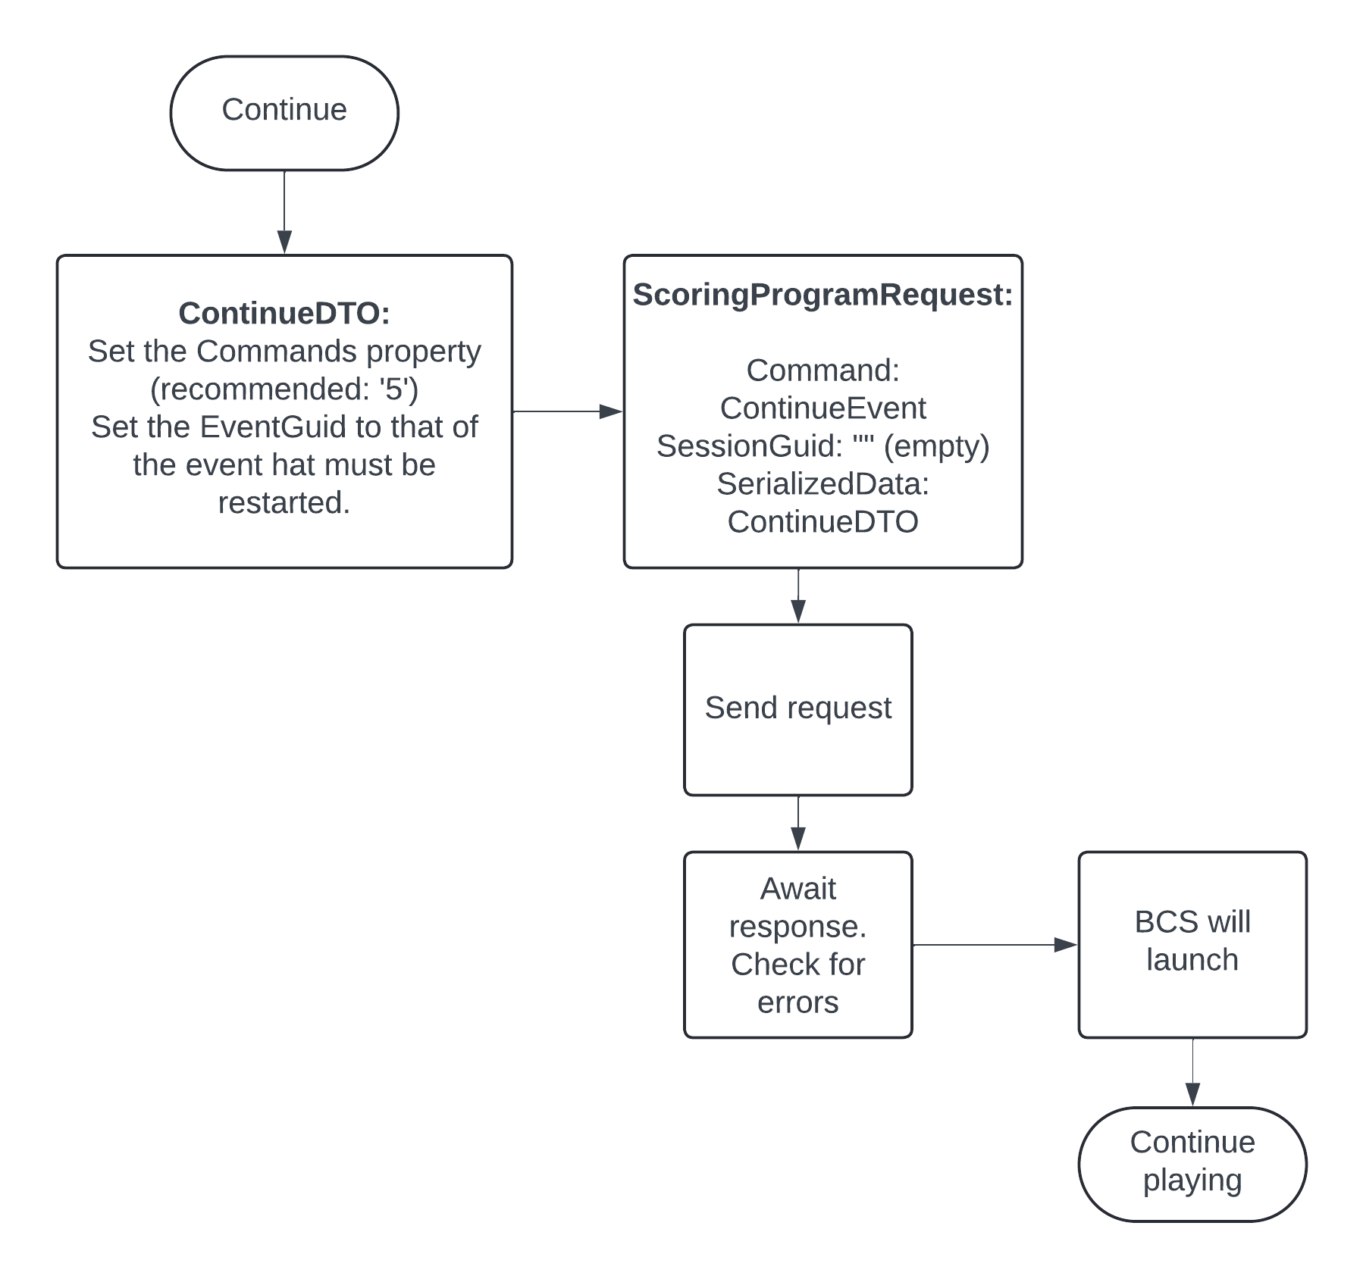

### Data structure



### Description

To continue a previously initialized event with its sessions use the ContinueEvent command and a ContinueDTO. The SessionGuid must not be set in the ScoringProgramRequest. This DTO must contain a valid EventGuid.

Furthermore, the ContinueDTO contains a Commands property that specifies which actions the Bridgemate Control Software must undertake when it has been launched.

### Example json code

The code below shows json data that needs to be sent to continue a previously initialized event.

{

"Command":30,

"SessionGuid":"",

"SeriallizedData":

{

"EventGuid": "6D115AF1ABEB4462A299B1FE86274949",

"Commands": 5,

"AlternativeDataFolder": null

}

}

**Update Bridgemate settings**

### Procedure

### 

### Data structure



### Description

Bridgemate settings can be included int the InitDTO when initializing the event, or can be updated later using the PutBridgemate2Settings command or the PutBridgemate3Settings command. These commands use the Bridgemate2SettingsDTO and Bridgemate3SettingsDTO respectively. The settings must be updated for all sections in the event, even if they are the same.

### Example json code

The code below shows json data that needs to be sent to update the Bridgemate 3 settings for a section. Updating the Bridgemate 2 settings will have a similar structure, but with different setting properties.

**Update the movement for a section or add one**

### 

### Data structure



### Description

#### Update the movement for a section or add a section

When after the play of the session has started the need arises to adjust the movements, the movement for a section can be updated, or a section can be added, using a SectionUpdateDTO and the UpdateMovementCommand. Reasons for such an update could be a pair arriving late or playing a Swiss pairs event, The update is communicated to the Bridgemate Data Connector by sending a SectionDTO that contains the new movement data for the section. On reception of this data BCS will figure out how to update the section. Movements are expressed by adding the tables and their rounds to the section.

The ScoringProgramResponse, if successful, contains a SectionDTO in its SerializedData property that specifies which rounds have been updated: Each round below the first specified round on a table is unchanged, each round above the last specified round will be deleted.

#### Adding a section

Adding a section works the same way. The Bridgemate Data Connector will detect that the secion did not exist before and will add it.

**Note**

* Do not forget to send a Bridgemate2SettingsDTO or a Bridgemate3SettingsDTO for a new section.
* Boardresults will be deleted from the first round where the round data for a table has changed. The ScoringProgramResponse contains the rounds (as a SectionDTO) for which this is the case. If applicable send the results for these rounds again (but as a rule it should not apply).

**Delete a section**

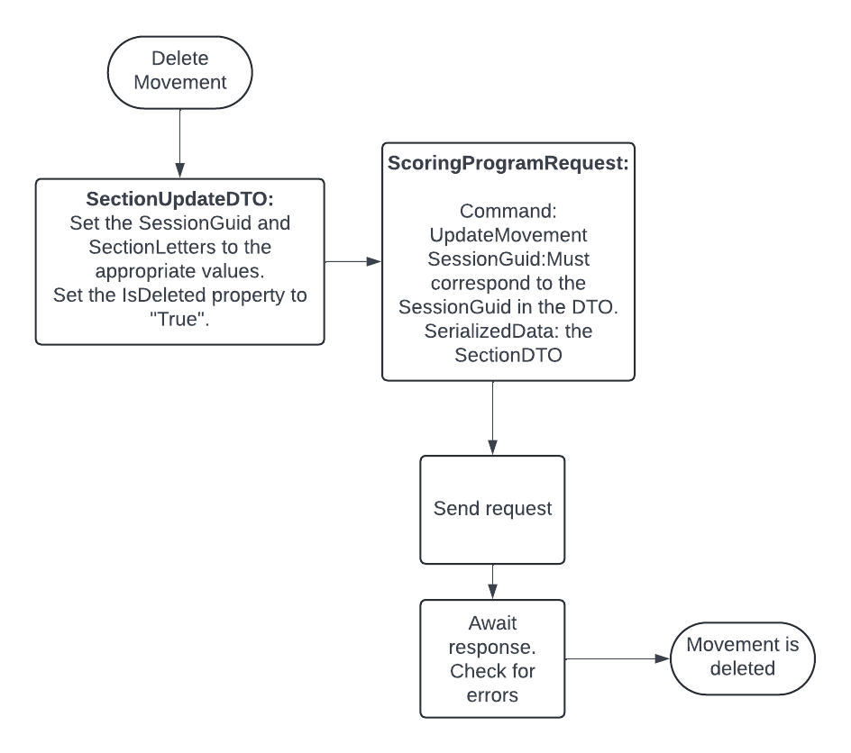

### Description

To delete a section Send a SectionUpdateDTO with its IsDeleted property set to "True" using the UpdateMovement command.

**Update scoringgroups**

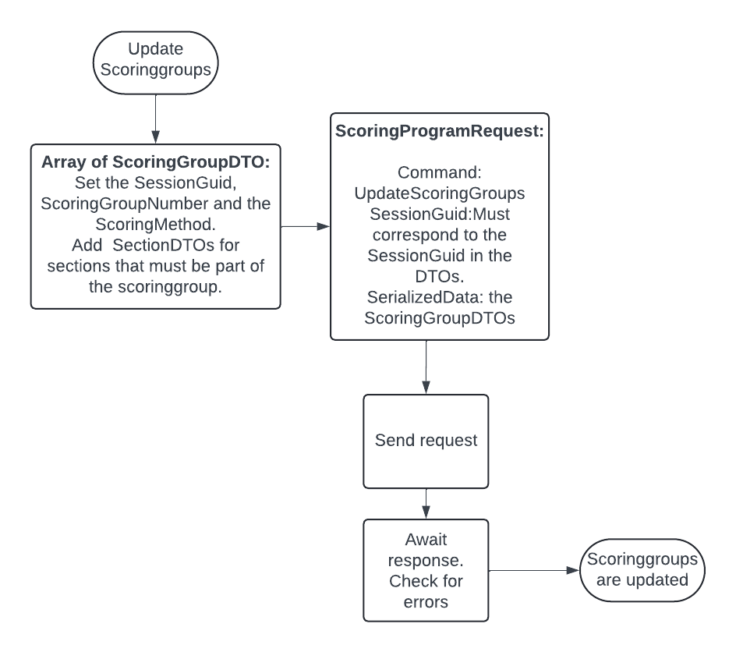

### Data structure



### Description

The configuration of the scoringgroups can be upated using a ScoringGroupDTO and attachting the SectionDTOs to it that should beccome part of it. Send the ScoringGroupDTOs using the UpdateScoringGroups command. Mind that each section must have a scoringgroup, so take care that no section is without one. Existing scoringgroups will be updated, the rest will be added.

**Note**  
When adding a section that will be part of a new scoringgroup be sure to add the scoringgroup first.

**Delete scoringgroups**

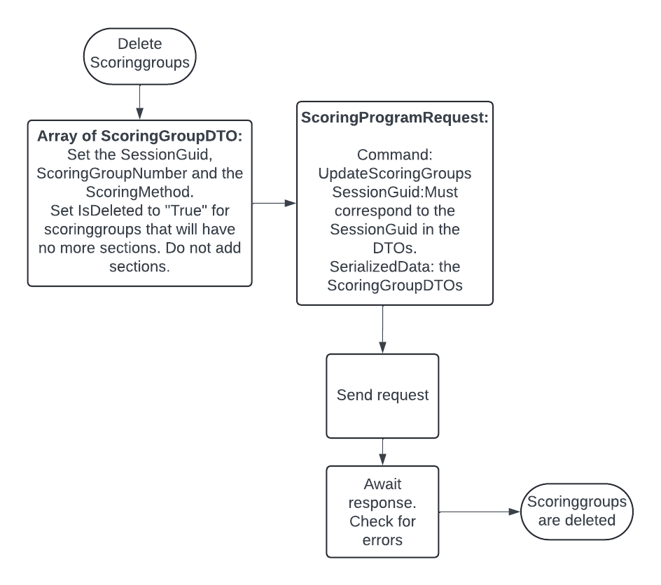

### Description

To delete scoringgroups send ScoringGroupDTOs with their IsDeleted property set to "True" using a UpdateScoringGroupsCommand. Do not add any sections to the scoringgroups. A scoringgroup cannot be deleted while it has sections attached to it. Update the scoringgroups first to assign the sections of the to be deleted scoringgroup an exisiting or new scoringgroup.

**Update player data**

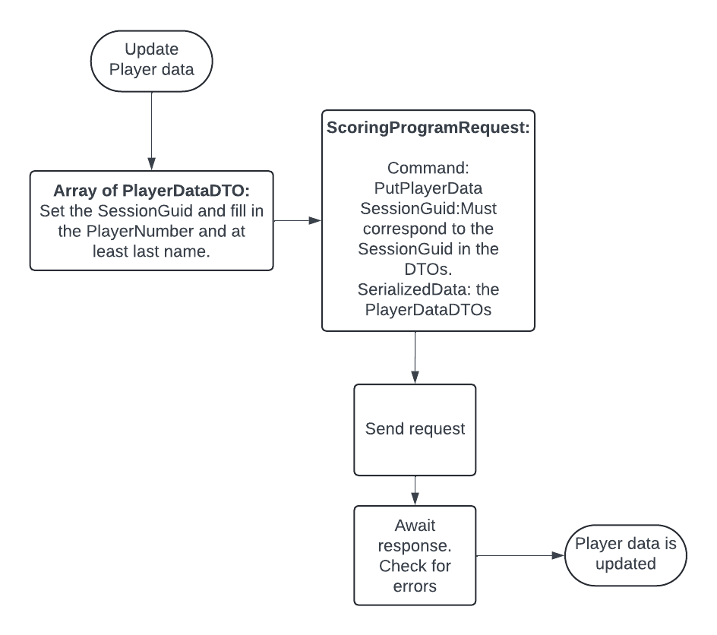

### Description

Player data can be updated with an array of PlayerDataDTOs using the PutPlayerData command. Existing player data will be updated, enabling changing first name, last name and country code, the rest will be added. Each ParticipationDTO that is sent to the Bridgemate Data Connector with its SessionGuid and PlayerNumber propertes set must have a corresponding PlayerData that was sent before. Player data preferably is sent with the InitDTO while initializing the event: this is more performant. Use the updates for movement changes after the event has started.

**Update participations**

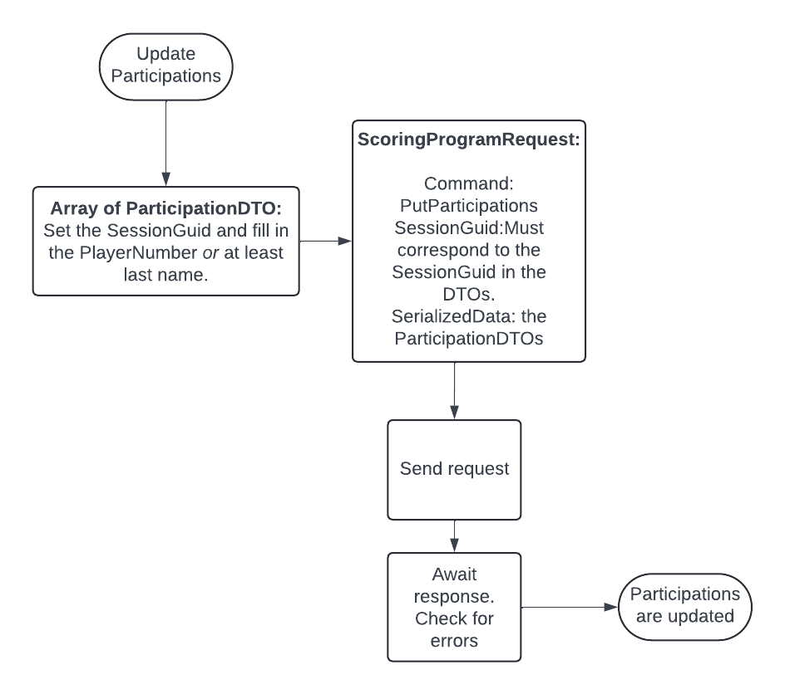

### Description

Participations can be updated with an array of ParticipationDTOs using the PutParticipations command. Existing participations will be updated, enabling changing the player in a pair, the rest will be added. Each ParticipationDTO that is sent to the Bridgemate Data Connector with its SessionGuid and PlayerNumber propertes set must have a corresponding PlayerData that was sent before. Participations preferably are sent with the InitDTO while initializing the event: this is more performant. Use the updates for movement changes after the event has started.

**Note**

Currently only participations for round zero or one are accepted. BCS will calculate the participations for the subsequent rounds and add or update them.

**Update handrecords**

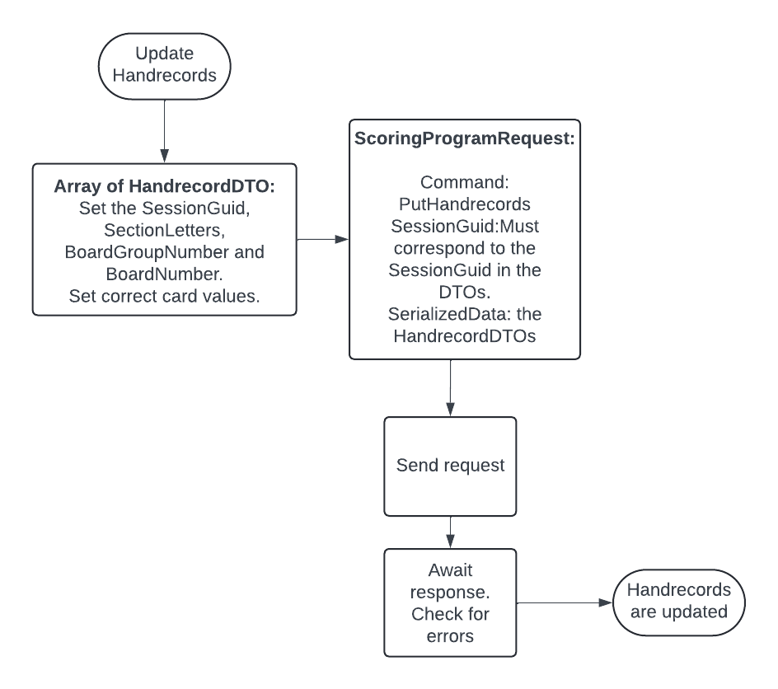

### Data structure



### Description

Handrecords can be updated with an array of HandrecordDTOs using the PutHandrecords command. Existing handrecords will be updated, the rest will be added. Handrecords preferably are sent with the InitDTO while initializing the event: this is more performant. Use the updates for movement changes or corrections after the event has started.

**Add a session**

### Procedure

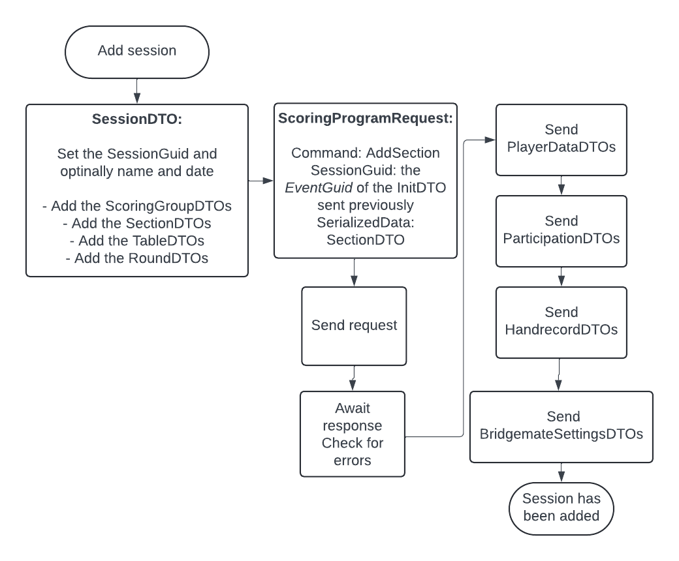

### Data structure



### Description

Using the InitDTO and the InitializeEvent command it is possible to start Bridgemate Control Software with more than one session. After initialization it is possible to add a section to one of the events that were initialized.

Apart from this it is possible to add a session after initialization. This works using a SessionDTO and the AddSession command.

* Set the ScoringProgramRequest.SessionGuid property to the *EventGuid* that was used when sending the InitDTO. Mind that when the event was initialized with one session and no event guid was specified at that time, the event guid will be equal to the single session's SessionGuid property.
* Add scoringgroups, sections, tables and rounds.
* Send the ScoringProgramRequest with the AddSection command.
* Optionally proceed with sennding playerdata, participations, handrecords and Bridgemate settings.

**Manage BCS**

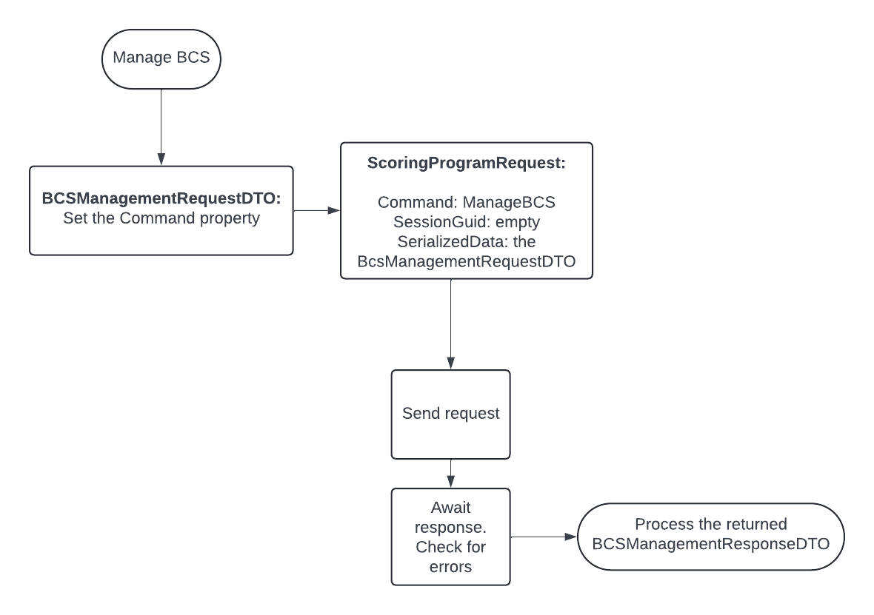

### Data structure



### Description

Using the BCSManagementRequestDTO and the ManageBCS command it is possible to query information about BCS' data and to issue a "Shut down now" command. In the last case the ScoringProgramResponse will not contain serialized data. In the other cases the response will carry a serialized BCSManagementResponseDTO.

### Example json code

An exmample request asking for the scoring file location and the currently administered sessions:

{

"SessionGuid":null,

"Command":,33.

"SerializedData":

"{

"Command":6

}"

}

SerilalizedData property of the scoring program response:

{

"EventGuid": "9B720E0FEBF741E9B3D4D9C4C71CD732",

"SessionInformation": [

{

"EventGuid": "9B720E0FEBF741E9B3D4D9C4C71CD732",

"SessionGuid": "9B720E0FEBF741E9B3D4D9C4C71CD732",

"SessionName": "Friday evening bridge",

"SessionDateTime": "2022-04-05T00:00:00"

}

],

"IsRunning": true,

"ScoringFilePath": "C:\\Users\\aners\\AppData\\Local\\BCS.Net\\ScoringFiles\\BridgeSystems.Bridgemate.BCSData.db",

}

An example request asking for the scoring file location and all sessions known to BCS:

{

"SessionGuid":null,

"Command":,33.

"SerializedData":

"{

"Command":8

}"

}

SerilalizedData property of the scoring program response:

{

"EventGuid": "",

"SessionInformation": [

{

"EventGuid": "7D20A8B6F2E7431F9D65B3FDDD874040",

"SessionGuid": "7D20A8B6F2E7431F9D65B3FDDD874040",

"SessionName": "Monday bridge",

"SessionDateTime": "2024-06-12T00:00:00"

},

{

"EventGuid": "AC46A9EFF3894F2D9A5434FCC76149F7",

"SessionGuid": "AC46A9EFF3894F2D9A5434FCC76149F7",

"SessionName": "Friday bridge",

"SessionDateTime": "2024-06-11T00:00:00"

},

{

"EventGuid": "ECE27FE8E19D4C72A57C759D460F8EB8",

"SessionGuid": "ECE27FE8E19D4C72A57C759D460F8EB8",

"SessionName": "Thursday bridge",

"SessionDateTime": "2024-06-10T00:00:00"

},

{

"EventGuid": "673B2AB4BA9F45BDB758026011F34B3E",

"SessionGuid": "673B2AB4BA9F45BDB758026011F34B3E",

"SessionName": "Qualification tournament",

"SessionDateTime": "2022-05-24T00:00:00"

}

],

"IsRunning": true,

"ScoringFilePath": "",

"ValidationMessages": null

}

**Explanation of used terms**

* BCS or Bridgemate Control Software: Windows software program to communicate with the Bridgemate base station, which communicates with the wireless Bridgemate terminals. Movement data is uploaded by this program to the base station, and results are retrieved from it the other way around.Without further specification the term "BCS" refers tot the newer, .Net based, version as the original, classic, version does not support use of the Bridgemate Data Connector.
* The (external) scoring program: Windows software program that is used for scoring bridge sessions, calculating results, printing rankings etc and which uses Bridgemates for input of results.
* The Data Connector:The Bridgemate Data Connector process: a messaging system to send requests and commands from the external scoring program to BCS and to receive data from BCS for the external scoring program.
* DTO: Data Transfer Object. A class or structure holding data for BCS, to be sent to it using the Data Connector. A DTO must be serialized as json in a request to the Data Connector and must be deserialzed from json when returned from the Data Connector
* The communication channel: the method used to exchange data with the Bridgemate Data Connector. The data will always be serialized as JSON. The transfer method currently is by using NamedPipes only.
* Event: one or more sessions that are grouped together in the Bridgemate servers.
* Session: a separately scored group of sections.
* Sit-out: a round on a table where a pair has no opponent.
* Empty table: a round on a table without pairs.
* Participation: the position of a player on a table in a given round, identified by his playernumber.